Four of Ohio’s 10 Most Common Jobs Pay Near Poverty Level
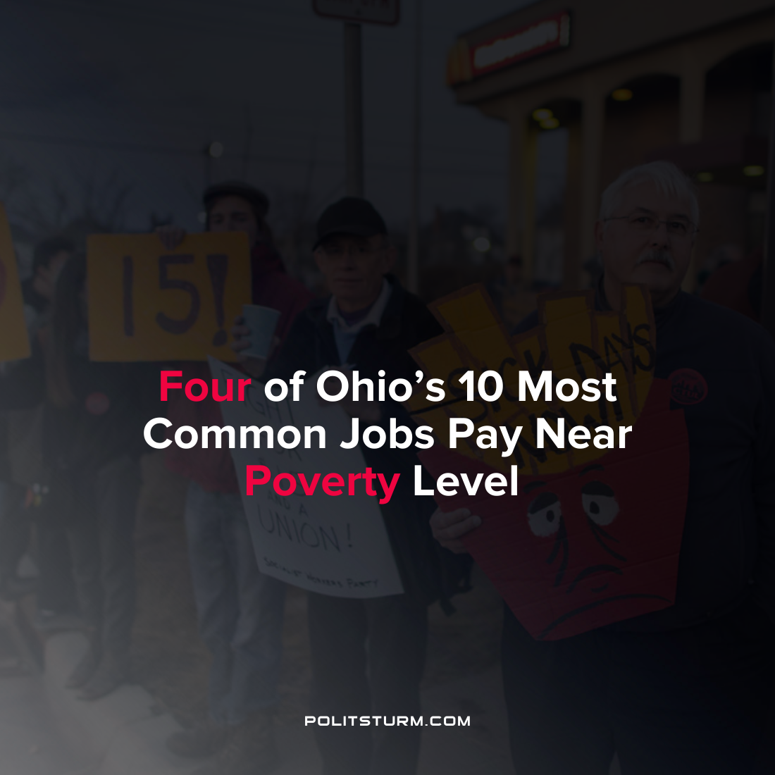

Original article
2022-04-28
1 min read

Progressive think tank Policy Matters Ohio examined Bureau of Labor Statistics (BLS) data on employment and wage data to analyze wage trends for the most common jobs in the state. What the data showed was that for many of the most common occupations held by hundreds of thousands of workers, pay was near the poverty level.

Four of the top ten most common jobs did not pay workers a sufficient wage in order to support a family of three. These occupations were fast food workers, retail salespeople, cashiers, and home health and personal health care aides.

“Pressures from the pandemic and intervention from the federal government pushed employers to increase pay. However, considering that corporations suppressed wages for two decades before COVID, the increases are modest at best. Now as a whole, working Ohioans are paid on par with the inadequate wages of the early 2000s. Since then, most working people haven’t shared in the exploding wealth their work helped create.” said Policy Matters researcher Michael Shields.

As industrial production has moved abroad in search of higher profit rates, the midwest has suffered a loss of industrial production jobs and now low-paying service jobs are common. Manufacturing employment in the Midwest declined from 5.1 million in 1990 to 4.1 million in 2019 and suffered near continuous job losses in this sector through the 2000s.

Now, low-wage service jobs are amongst the most popular jobs in Ohio and as inflation rises with minimal wages increases, these workers are hit the hardest. Regardless of whether capitalists are exploiting workers abroad or domestically, they thrive and profit off the low wages of workers and have no concern for the social ramifications of their private actions.
Sources: 1 2

Original article

