“Forever Chemicals” Found in Nearly Half of U.S. Tap Water Supplies
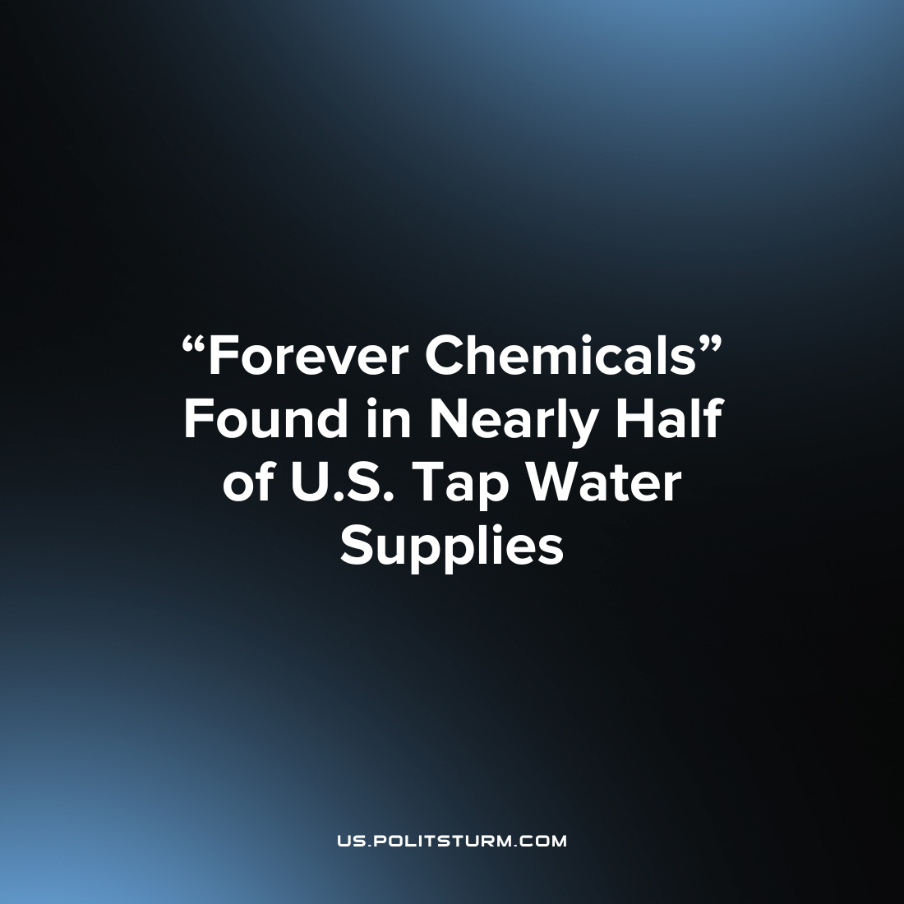

Original article
2023-08-19
1 min read

In a recent study, the US Geological Survey (USGS) has examined tap water from both private and public water supplies across the country to test for and compare levels of per- and polyfluoroalkyl substances (PFAS). The study provided valuable insights into the extent of PFAS contamination in drinking water. PFAS are synthetic chemicals found in various everyday items, including food packaging, cookware, and firefighting foams. High concentrations of PFAS have been linked to adverse health effects, although further research is needed to fully understand the full long-term impact of PFAS exposure. These chemicals are known as "forever chemicals" due to their slow breakdown and widespread presence in the environment.
The USGS study involved collecting tap water samples directly from kitchen sinks nationwide, allowing for a comprehensive assessment of PFAS levels in both public and private water supplies. The results indicate that at least one type of PFAS is present in almost half of tap water across the US. Moreover, there were similar concentrations of PFAS in both public supplies and private wells. The study tested for 32 individual PFAS compounds using a method developed by the USGS National Water Quality Laboratory. The most frequently detected compounds were PFBS, PFHxS, and PFOA. It is worth noting that the study found that the levels of PFOS and PFOA, two PFAS compounds, exceeded the interim health advisories provided by the US Environmental Protection Agency (EPA) in 2022 whenever they were detected in the samples.
Under capitalism the ‘externalities’ of the production and consumption of commodities can impact the environment as it is not in the profit-interest of any individual capitalist to control such variables. One of the main avenues through which PFAs make their way into the water supply is through the industrial production of commodities, the entire process of which is under the control of the capitalist class which is lightly regulated by the legislative bodies under their control. The consequences of these negative ‘externalities’ ultimately fall upon the masses of workers.
Sources: 1 2

Original article

