Ford Executive Calls On Auto Workers to End Strike
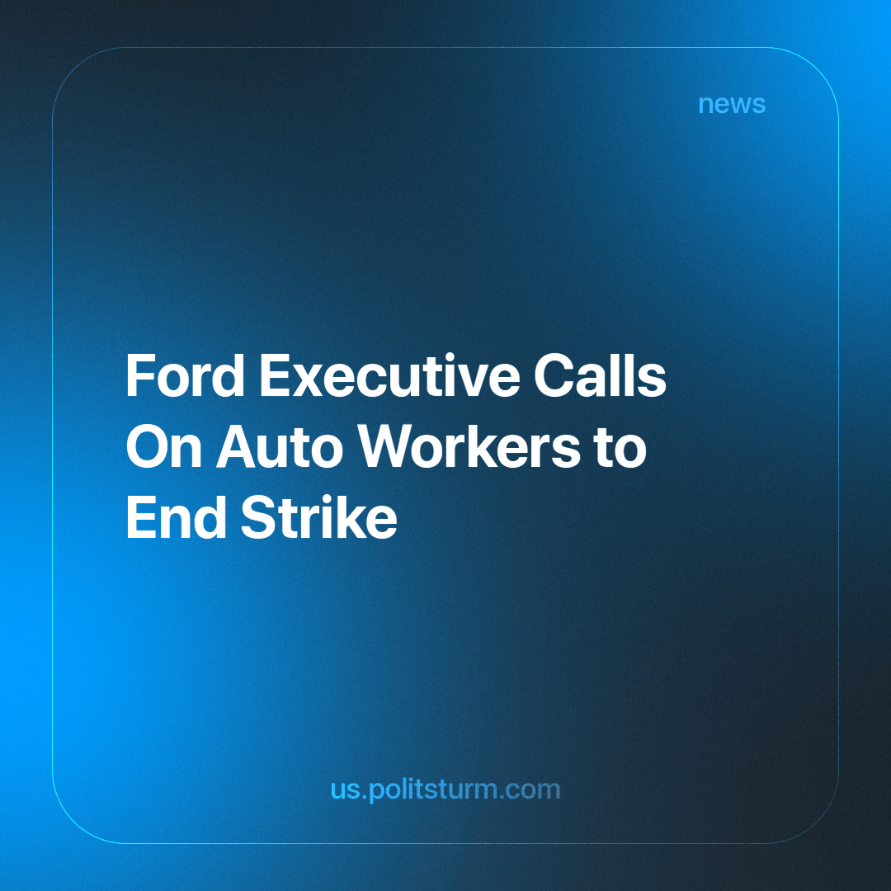

Original article
2023-10-19
1 min read

Ford Motor Co. Executive Chairman Bill Ford called on auto workers to end a month-long strike that, as he says, could cost the company the ability to invest in the future. The company is near an impasse with the United Auto Workers union, which walked out in targeted strikes at all three Detroit auto makers on September, 15.
Last week, 8,700 union members walked out at the largest and most profitable Ford plant in the world, the Kentucky Truck Plant in Louisville, because Ford is paying workers of the
Ford factory only about $3 per hour. CEO of Ford Jim Farley in that time has raised $21 million per year.
“Ford’s offer of a 23% general wage increase barely covers inflation over the last three or four years,” said one of Ford’s employees. Another Ford employee stated, “We shouldn’t have to suffer, especially for the retirees,” and “they need to pay us what we deserve.” The union has said retirees haven’t received a pension increase for at least a decade.
In response, Ford's CEO countered with a statement: “We have been very clear we are at the limit,” and “We risk the ability to invest in the business and profitably grow. And profitable growth is in the best interest of everybody at Ford”.
The interest of capitalists lies in extracting labor value from workers. Profitability is inherently against the workers, as it is the extraction of their labor value. The CEO is against the workers, and it is specifically clear in this case, as high profits have not correlated with better working conditions and better pay, the opposite is true.
It is in the interest of workers to form unions to have more collective power for bargaining against the capitalist class, only then do they get the concessions. Not just form trade unions, but rather struggle to replace the whole economic system with a socialist one. Only through the formation of a vanguard party and a socialist movement can capitalism’s exploitation be overcome.
Sources
https://apnews.com/article/bill-ford-executive-chairman-uaw-contract-talks-27b702b36599bf1706e1c692ccfda1c6
https://www.nytimes.com/2023/05/02/business/ford-motor-earnings-q1.html

Original article

