Food Sanitation Company Pays Fine For Illegally Employing More Than 100 Children
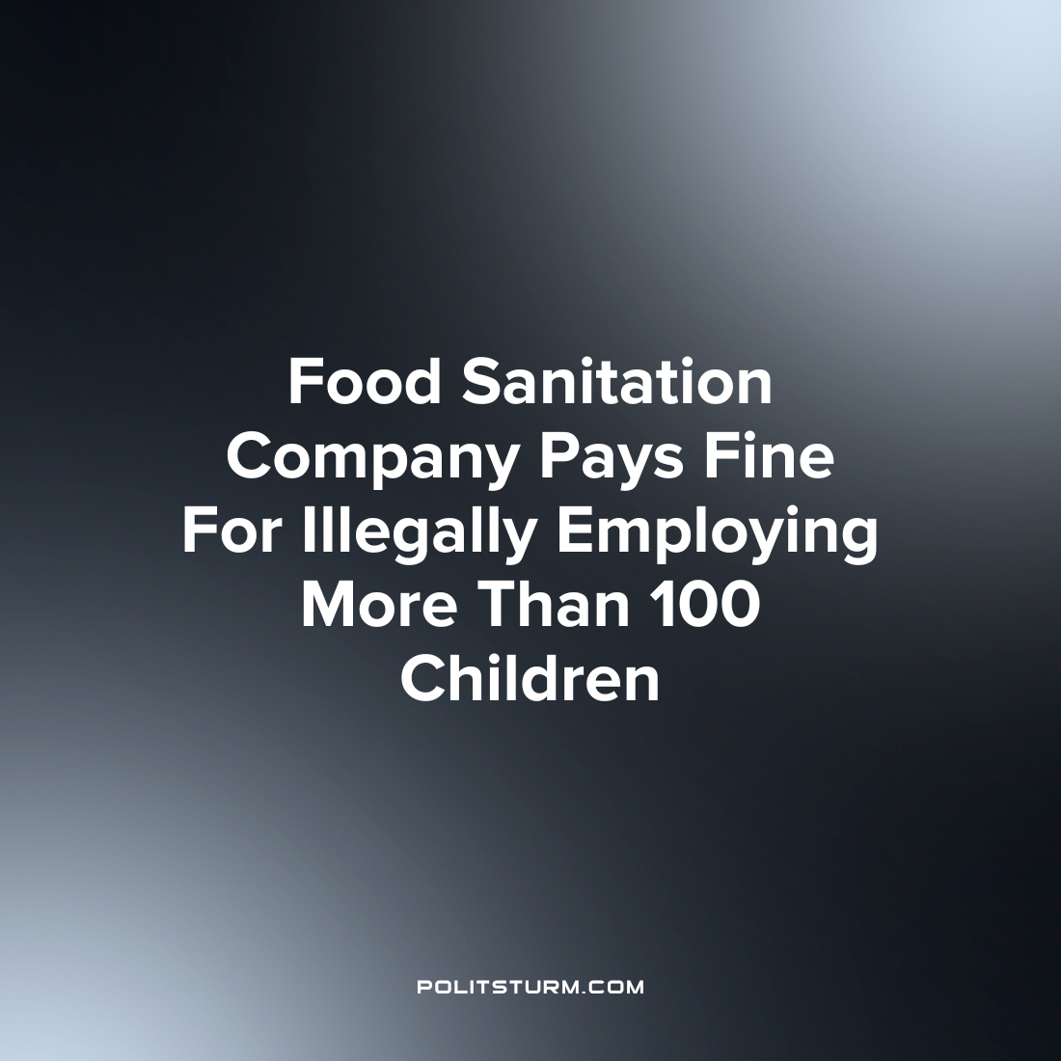

Original article
2023-02-22
1 min read

The U.S. Department of Labor (DOL) announced that it collected a fine of $1.5 million in civil penalties from Packers Sanitation Services Inc., a food safety sanitation provider. Investigators found that the company employed at least 102 minors aged 13-17 in dangerous occupations at 13 meat processing plants across 8 states.
The children were employed cleaning powered equipment on overnight shifts at some of the largest meat processors in the U.S. including JBS, Tyson, and Cargill.
“These children should never have been employed in meat packing plants and this can only happen when employers do not take responsibility to prevent child labor violations from occurring in the first place”, said DOL Principal Deputy Administrator Jessica Looman.
While it may be stated that the company did not “take responsibility for preventing child labor violations”, the release indicated that this was not a passive oversight. Rather, the company actively tried to prevent regulators from investigating their labor practices and tried to “derail” such efforts.
The DOL assessed a paltry fine which is just a fraction of the company’s revenue. Under capitalism, the profit motive is the key driving force of production and the safety and wellbeing of the workers is a secondary concern. It is unreasonable to conclude that such practices which undermine the safety and livelihood of workers can be prevented under capitalism when an employer can get a competitive advantage by violating labor laws and simply paying the insignificant fines as a cost of doing business.
Source: 1

Original article

