Food Prices Expected to Rise Through 2022
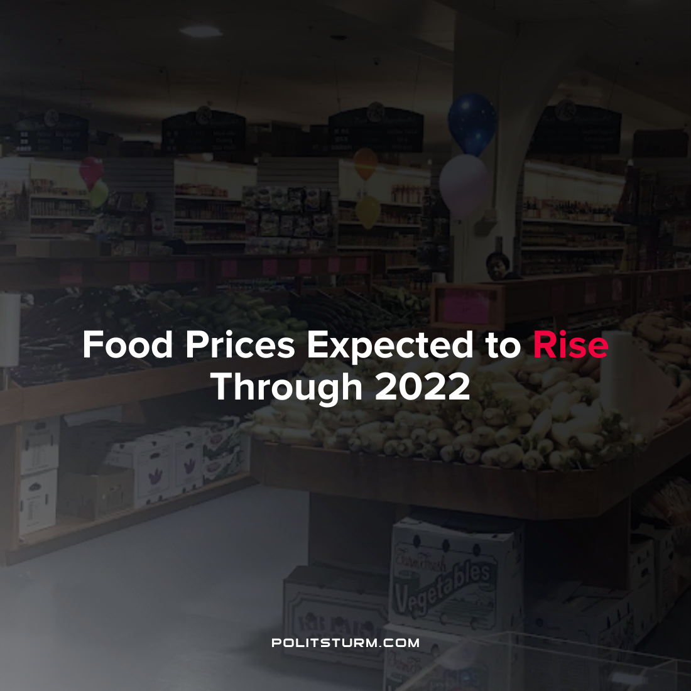

Original article
2022-03-29
1 min read

The United States Department of Agriculture predicts that rising food prices will persist in the U.S. in the near future. Food prices as of February 2022 were 7.9% higher than they were one year ago and both food purchased from restaurants and supermarkets were affected. For 2022, at-home food prices are expected to rise another 3-4% whereas away-from-home food prices are expected to rise between 5.5-6.5%.
Poultry prices are expected to rise between 6-7%. Dairy is expected to increase between 4-5% whereas fresh fruits and vegetables are expected to rise 5-6%.
The department estimates that wholesale prices are expected to increase dramatically for a wide array of food commodities which will lead to higher retail food prices.
While the capitalists are able to charge higher prices for their commodities with inflation, the working class around the world will feel the brunt of the negative effects, particularly the lowest wage workers. The increase in food prices will undoubtedly hit these workers the hardest as real wages decline and food takes up a large part of their wage income. As always, the contradictions of the capitalist economic system are pushed onto the working class, while the bourgeois class reap the private profits.
Source: 1

Original article

