Food Price Index Rises 20% Since 2021
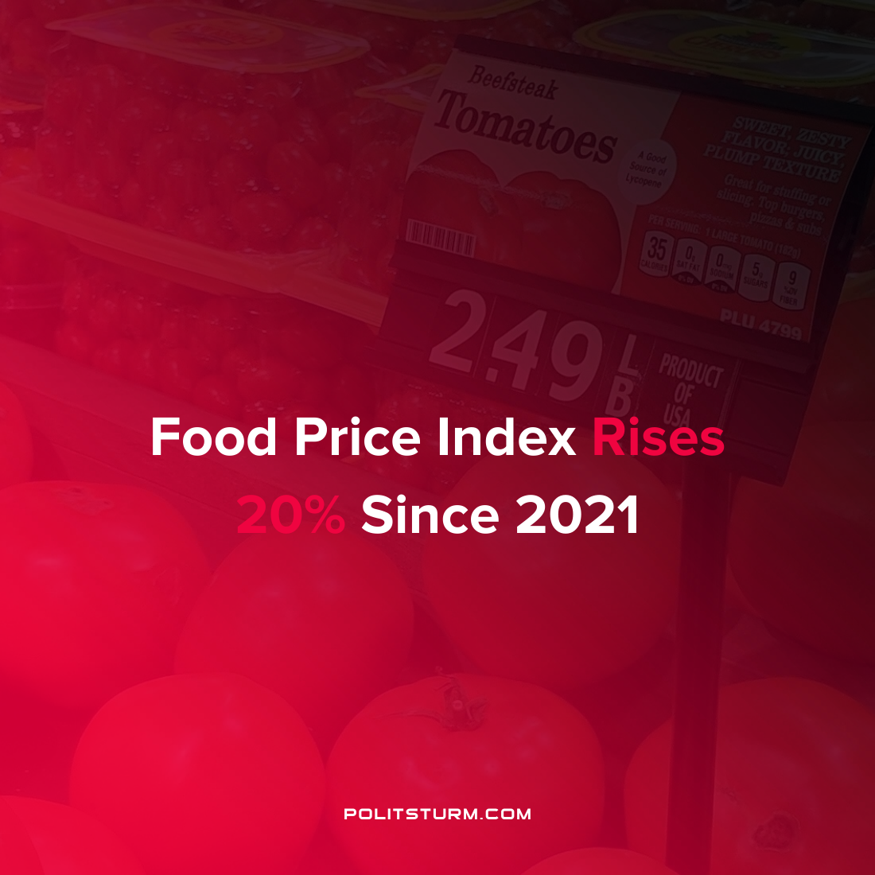

Original article
2022-03-25
1 min read

According to data released by the Food and Agriculture Organization, the price of food has skyrocketed over the last year. The Food Price Index, measuring the international prices of a basket of food commodities, has been on a sustained increase since the beginning of 2021. The food prices measured by the index increased 20.7% over the last year and were up 3.9% in the last year alone.

Large increases in the index were driven by increases in vegetable oil, dairy, cereals, and meat prices. From a historical perspective, real food prices have not been this expensive since the 1970s.

Error loading image
Source: FAO Food Price Index

The increases in food prices are going to strain those with the lowest incomes and wealth while the capitalists will continue to be able to sell their commodities at higher prices. The capitalist economic system is characterized by the anarchy of production which is subject to periodic crisis and instability. As is always the case the bourgeoisie will continue to profit while the majority of the population live with the consequences of price instability.
Source: 1

Original article

