Florida Governor DeSantis Signs New Restrictive Immigration Law
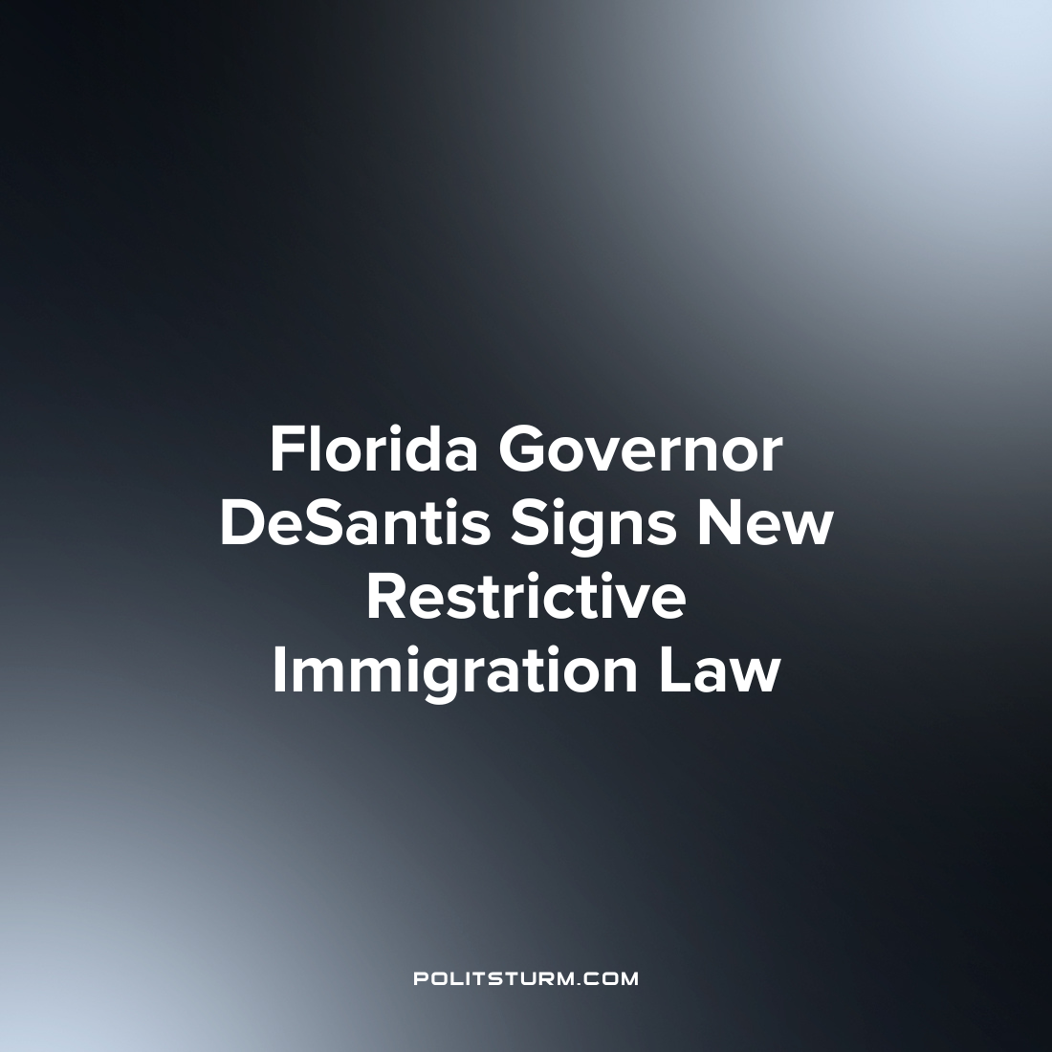

Original article
2023-05-21
1 min read

Florida governor Ron DeSantis recently signed a new bill into law which imposes new restrictions on undocumented immigrants in the state. DeSantis stated that “Biden’s Border Crisis is a catastrophe…Today I signed legislation to combat illegal immigration and to deter illegal immigrants from coming to Florida.”
The bill, SB 1718, is one of the toughest immigration laws in the country and requires private employers with 25 employees or more and public agencies to use the Federal e-Verify system to verify employment. The bill also invalidates out of state drivers' licenses issued to “unauthorized immigrants”. Citizens can be charged with a first-degree felony if they are found transporting an undocumented immigrant into Florida. The bill also appropriates funds to DeSantis’ “unauthorized immigrant transfer program” through which he had previously flown Venezuelan immigrants from Texas to Martha’s Vineyard in a political stunt.
Desantis, who is vying to be the 2024 Republican Presidential candidate, has taken a hardline stance against undocumented immigrants. Instead of criticizing the exploitative capitalist system which leads to unemployment and instability, the capitalists scapegoat immigrants in an attempt to divert dissatisfaction onto a specific vulnerable population. On the one hand, U.S. employers exploit undocumented workers due to their precarious legal status and want to utilize their labor power for profit. On the other hand, undocumented immigrants are targeted by the racists and chauvinists of the ruling class and their supporters as a cause of instability within the U.S. under the pretext of a supposed “crisis”.
Source: 1, 2

Original article

