Five Myths About the Soviet Union
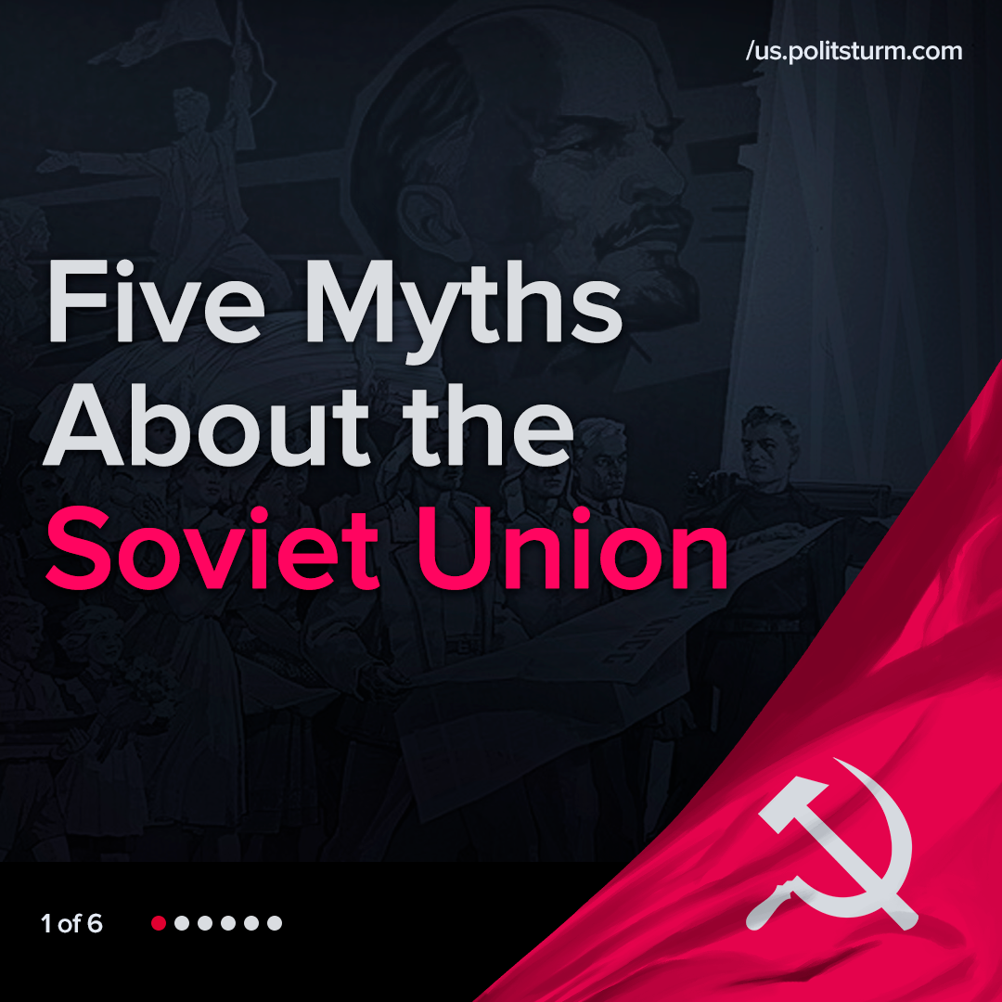

Original article
2022-02-18
1 min read

Error loading image
Error loading image
Error loading image
Error loading image
Error loading image

Original article

