Finland is Facing a Wave of Strikes
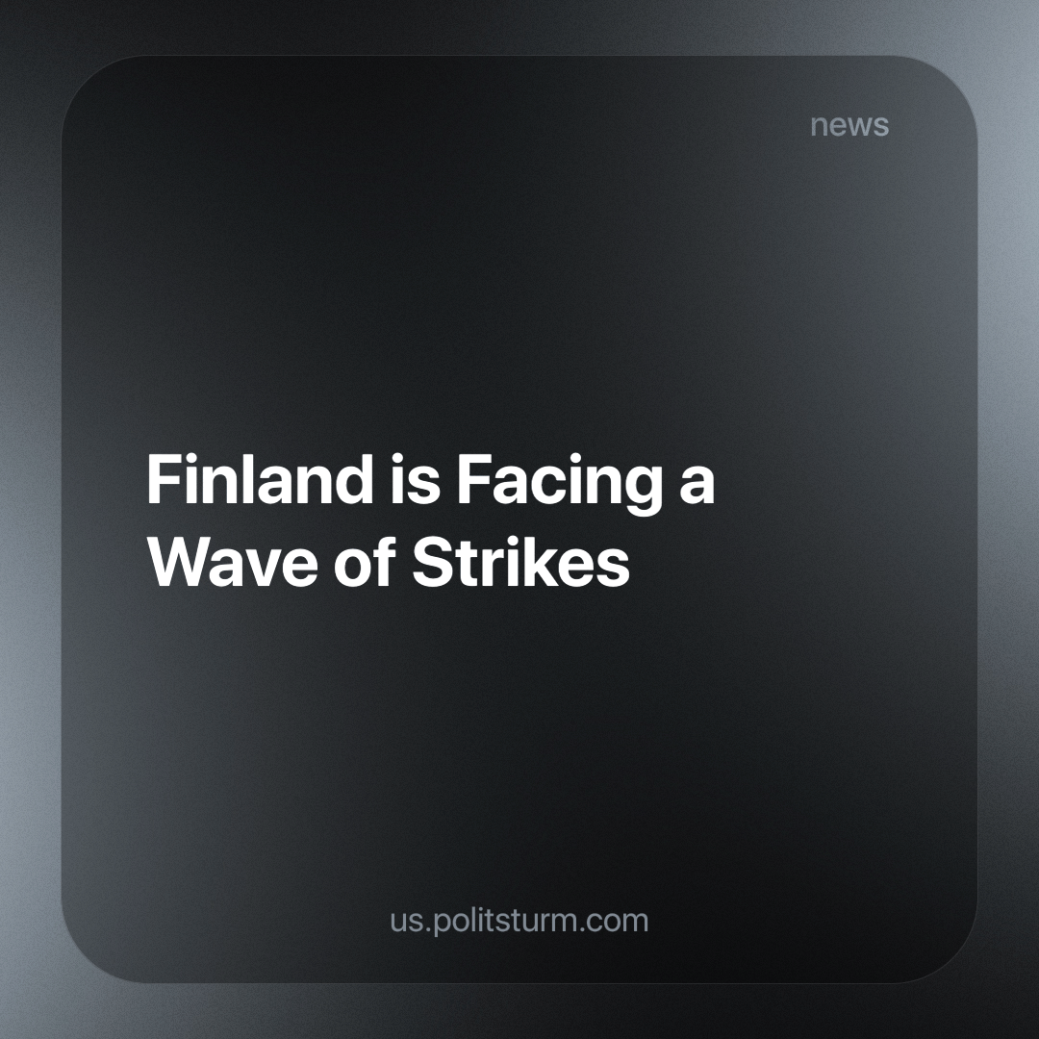

Original article
2024-02-17
3 min read

Finland has experienced a significant shutdown in various sectors this week as about 130,000 workers went on strike in protest against government labor market reforms proposed by the administration of Prime Minister Petteri Orpo. These politically motivated strikes are expected to hit recent reforms that reduce workers' rights, as Politsturm wrote earlier.
The strikes peaked at the end of the week, as more than 100,000 employees took to the streets from Wednesday to Friday. The Confederation of Finnish Industry (EK) estimates the cost of these strikes, along with those that have already taken place since December, at about one billion euros.
Important industries such as rail transport, healthcare and education have been on strike since Monday.
The industrial sector came to a standstill on Wednesday as political strikes by the Industrial Union and Pro Union affected various industries. About 60,000 industrial workers and 7,000 office workers are expected to join the strikes, potentially shutting down a significant portion of Finnish industry.
Public transport in Helsinki, Tampere and Turku will also be halted due to the JHL’s strike, which affects the movement of trams, subways and buses. Ports have been paralyzed due to the strike of dockers by the AKT union from Wednesday to Friday.
From Thursday, the strikes spread to the energy sector, and the Electrical Workers' Union moved its political strike from the Loviisa nuclear power plant to the Olkiluoto nuclear facility. Other ongoing strikes include strikes by the Service Union United (PAM) at logistics centers and by the Food Workers’ Unions SEL and Pro Union at some food processing plants.
On Friday, the strikes expanded to include workers at the Kemijoki, Tornionlaakson Voima and Pohjolan Voima hydroelectric power plants, as well as Fortum's Oulujoki hydroelectric power plants, all of whom are members of the Electrical Workers' Union [1].

Will these actions be able to turn the tide of events?
At the moment, the ruling class of Finland remains calm and does not shift its position one iota. Moreover, despite the unpopular reforms, Alexander Stubb, a candidate from the right-wing National Coalition Party (NCP), was recently elected in the second round in the country [2]. Stubb is from the same party that previously proposed pension reform, a ban on strikes and "competitive" transformations in the labor market.
Finnish Prime Minister Petteri Orpo has once again announced that he will promote these reforms despite the fact that he admits that strikes that they provoke cause "huge damage" to the economy. And on February 13, Orpo made another statement that the government would take even stricter measures [3].
Unfortunately, the events in Finland show that scattered, spontaneous, non-concentrated strikes and actions do not lead to results. Even after accepting the loss of a billion euros in a few months, the bourgeoisie knows it can compensate for these costs by reaping the future benefits of the reforms.
In Finland, it is necessary to create a workers' party that will unite the mood of protest and the will of the people into a single fist, acting as the vanguard of the working class. Because of its absence, the bourgeoisie can still “sell” to the population a political show in the form of presidential and parliamentary elections, in which both the Social Democrats and the right-wing populist parties defend the interests of the bourgeoisie. In the era of imperialism, it is foolish and even dangerous to hope that the ruling class, which has an army, police, and state in its hands, will just fairly go to meet disorganized workers and make significant concessions to the detriment of their own benefit.
Most likely, we will see token concessions towards some section of the striking workers who will withdraw from the national strikes, thereby weakening the general protest movement and the common effort of the workers will be broken apart. To avoid this, workers need to be able to organize themselves into a force capable of effectively retaliating in the political sphere. If you want to learn how and help us with this, join Politsturm.
Sources: 1, 2, 3

Original article

