Fiat Chrysler Guilty of Bribing UAW Officials
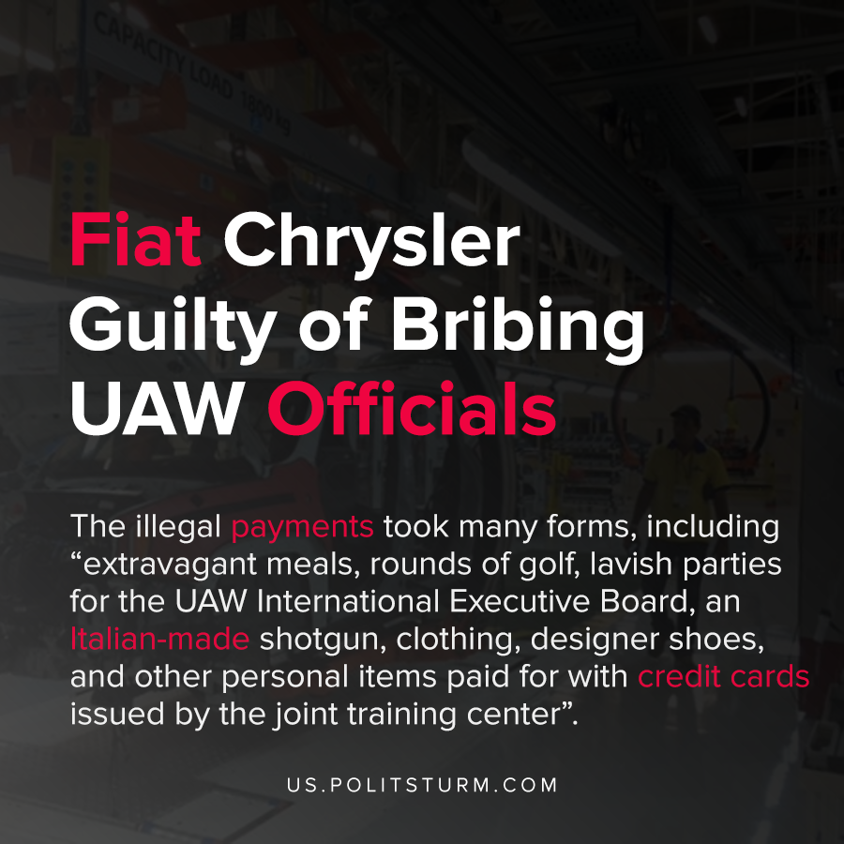

Original article
2021-03-04
1 min read

Fiat Chrysler Automobiles, one of the three large American automobile manufacturers, admitted to making $3.5 million in illegal union payments. Between the years 2009-2016 payments were made to International Union, United Automobile, Aerospace, and Agricultural Implement Workers of America (UAW).
A representative for the company admitted that the company broke the Taft-Hartley Act by making illegal payments to union officers.
The illegal payments took many forms, including “extravagant meals, rounds of golf, lavish parties for the UAW International Executive Board, an Italian-made shotgun, clothing, designer shoes, and other personal items paid for with credit cards issued by the joint training center”.
It also turns out that the company made payments to $262,000 to pay off the mortgage of UAW Vice President General Holiefield.
The United States entered into a plea agreement with Fiat Chrysler. As a result of the admission of guilt, Fiat Chrysler will pay a $30 million fine and will be on probation for three years to monitor compliance to federal labor laws.
The company openly admitted to the conspiracy and illegal payments which shows the close connection between the capitalists and top union leadership. The capitalists use a portion of their profits to bribe and corrupt the union leadership to serve the interests of the capitalist class, even to such an egregious degree that it is openly admitted.

Source: 1

Original article

