Fentanyl And Stimulants Cause 'Fourth Wave' Of Overdose Epidemic In U.S.
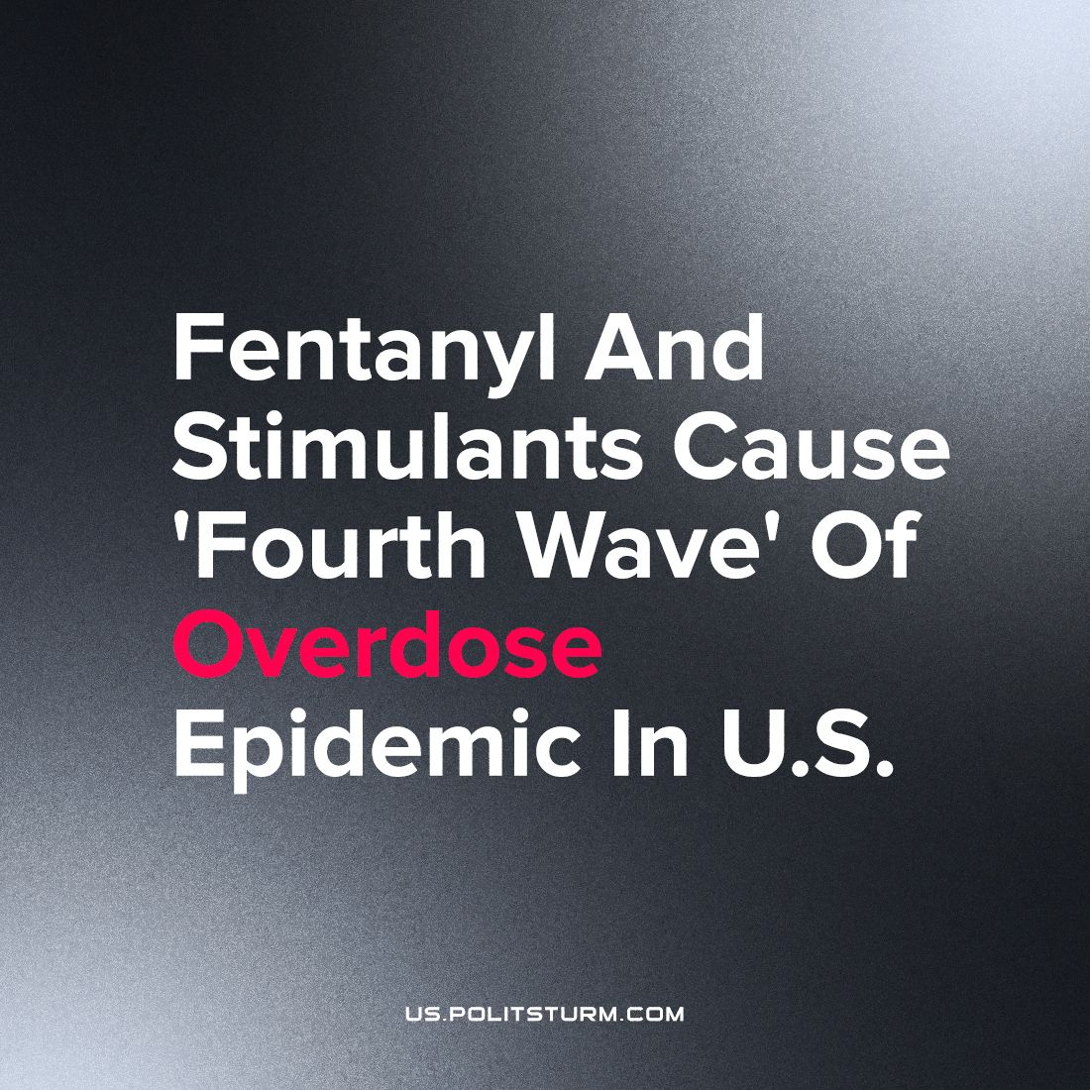

Original article
2023-10-01
1 min read

An NBC report has found that overdose deaths in the U.S. totalled over 100,000 for the first time in 2021, fueled by the rise of synthetic opioids, which accounted for 75% of those deaths. Past overdose epidemics were driven by prescription opioids and then heroin. The decade-long wave of an overdose epidemic has been driven by synthetic opioids since the mid-2010s.
An investigation found that the proportion of overdoses involving fentanyl and a stimulant — most commonly cocaine and methamphetamine — increased more than 50 times from 2010 to 2021, according to a study published Thursday in the journal Addiction.
In 2010 a report was published by the CDC that concluded, just over half a percent of fentanyl deaths, those of 235 people, involved stimulants. By 2021 the report stated, that nearly one-third of all fentanyl overdose deaths — those of more than 34,000 people — involved stimulants. Due to the fact, fentanyl is roughly 50 times more potent than heroin.
A proportion of the fentanyl-plus-stimulant overdoses may be due to the fact that fentanyl has now been found, often unexpectedly, in virtually every other illicit drug.
In the study, autopsy reports for people whose deaths were attributed to mixed drug overdoses. The study noted that significant amounts of both stimulants and fentanyl in their systems.
Drug epidemics and its impact has been horrendous for the U.S. The alienation and poor conditions of capitalism has made people resort to drugs to overcome, their isolation and conditions. This epidemic of substance abuse and others like it will continue so long as we have the current system of exploitation.
https://www.nbcnews.com/health/health-news/fentanyl-stimulants-drives-fourth-wave-overdose-epidemic-us-rcna104953

Original article

