Federal Reserve to Reverse Failed Monetary Program
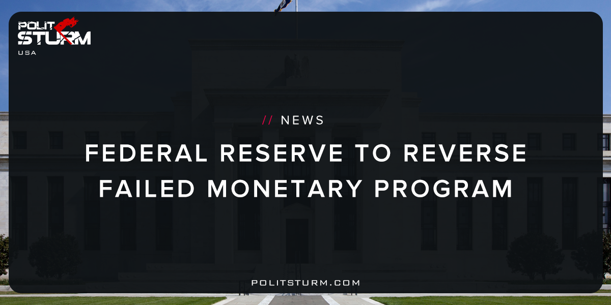

Original article
2017-09-24
1 min read
Sources: 1, 2, 3
The moment was hugely significant and yet so heavily flagged that it passed without a tremor in the financial markets. Federal Reserve chair Janet Yellen confirmed last Wednesday that the central bank would start to unwind the vast holdings of government and mortgage debt it acquired in the years following the 2008 financial crash.
The Fed, under former chairman Ben Bernanke, more than quadrupled the size of its balance sheet, to $4.5tn, by purchasing Treasury bonds and mortgage-backed securities under a programme dubbed quantitative easing (QE). Many were from the effectively bust Fannie Mae and Freddie Mac mortgage lenders.
Politsturm: In the wake of the last crisis of capitalist overproduction, the Federal Reserve increased its balance sheet at an unprecedented rate. Now with a bloated balance sheet, the decision has been made to roll back this process known as “Quantitative Easing”. As the program is now being reversed, leading bourgeois economists in the U.S admit that quantitative easing did very little, or was actually harmful to the so-called “recovery”. Increasing the money supply and the assets held by the central bank can in no way prevent the periodic crises of capitalism.
The thoroughly disproven economic theories used by the capitalist class blinds them to the laws that govern capitalist commodity production. Wherever you have commodity production, the law of value is operative. Under capitalism, there are recurrent crises as too many commodities are produced relative to the money commodity, which is gold. History has proven Karl Marx to be both theoretically and and historically correct in his proposition that bank authorities cannot control the excesses of capitalism by regulating the money supply. The Bank Act of 1844 showed this to be the case as the control of the money supply did nothing to prevent the crises of 1848 and 1857. Crises have continued since that point up until the present and modern economists are still holding patently false economic theories from the nineteenth century. We are repeating history but have progressed beyond tragedy. This is now a farce.

Original article

