Federal Reserve President Predicts 30% U.S. Unemployment
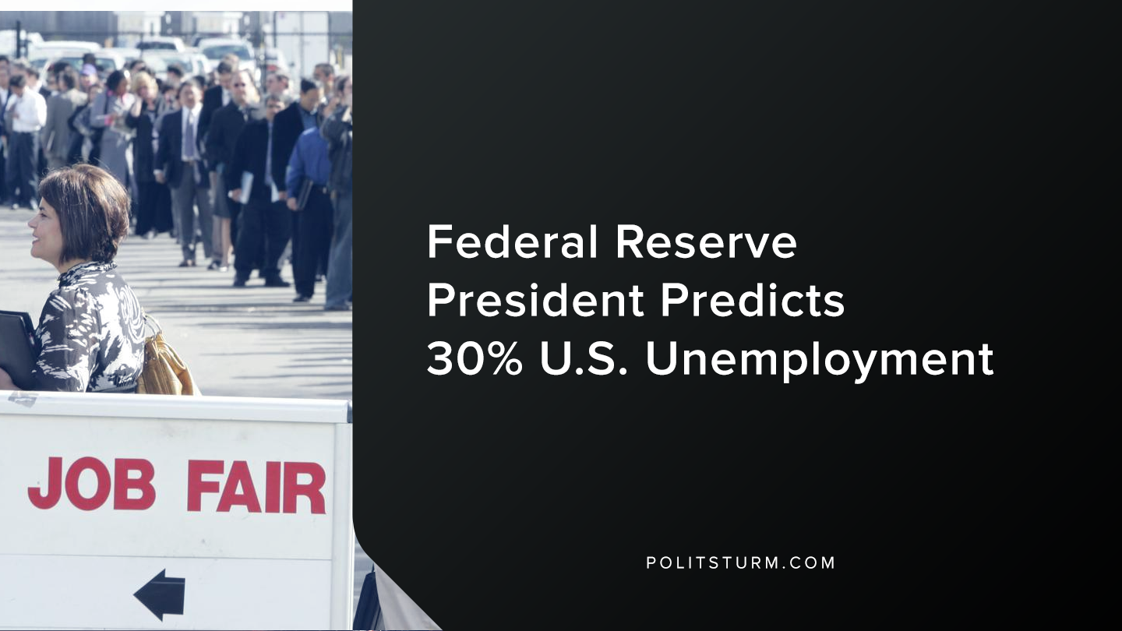

Original article
2020-03-27
1 min read

In a recent interview, the President of the Federal Reserve Bank of St. Louis James Bullard said that the U.S unemployment rate could reach as high as 30%. Bullard also stressed that the Federal Reserve was willing to examine all available options to attempt to mitigate the crisis.
The Federal Reserve has recently lowered interest rates and taken extraordinary action to calm the short-term credit markets and money-markets. Despite these monetary policies, with the onset of another crisis, Bullard expects that the unemployment will soar which means that the working class will suffer the consequences.
To put this figure into perspective, in February 2020 the unemployment rate was 3.5%. This figure only calculates individuals who are actively looking for work, and thus grossly underestimates unemployment. However, there have not been comparable unemployment figures in the United States since the Great Depression, so Bullard clearly has a negative outlook on the economy.
The capitalist system is subject to periodic crises, which throw the workers out of work needlessly to serve the interests of the capitalist class. While workers will potentially lose their incomes, the capitalists will continue to own the businesses, the stocks and real estate.
The only possible way to prevent the absurd situation where unemployment stands in contrast to declining industrial production, is the institution of a planned economy under the control of the working class.

https://www.sjsu.edu/faculty/watkins/dep1929.htm
https://www.bloomberg.com/news/articles/2020-03-22/fed-s-bullard-says-u-s-jobless-rate-may-soar-to-30-in-2q

Original article

