Federal reserve increases repurchase operations
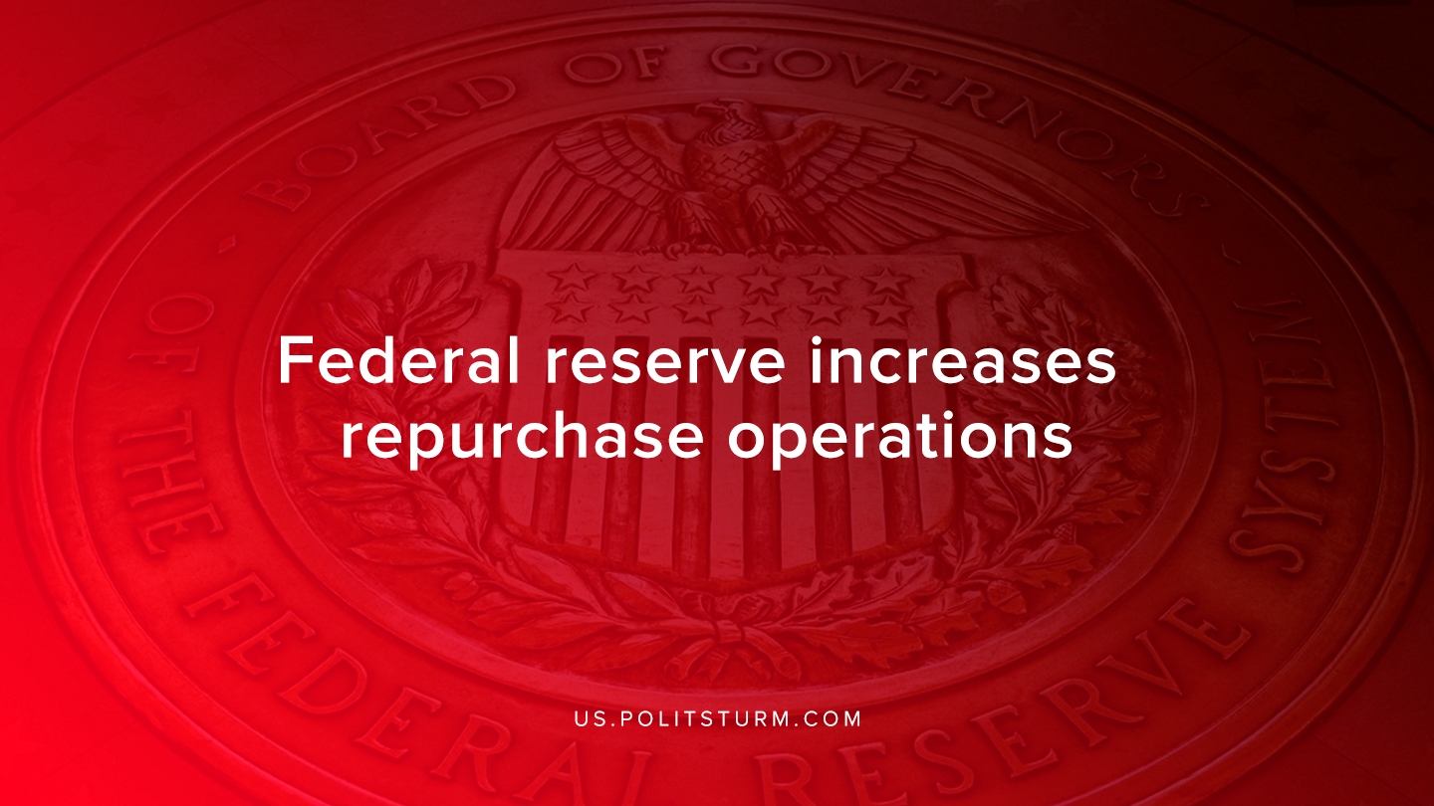

Original article
2020-03-14
1 min read

In response to tightening short-term credit markets, the Federal Reserve Bank of New York announced that it would be increasing the amounts of repurchase agreements, commonly referred to as “repos”. Repurchase agreements are a form of short-term borrowing through which the Federal Reserve is looking to supply credit to the money market.
Between March 9th and 12th, the Federal Reserve will increase overnight repo operations from $100 billion to $150 billion. It will also increase the amounts offered in two-week terms from $20 billion to $45 billion.
Through complicated financial operations the Federal Reserve is intending to support the money market and “mitigate the risk of money market pressures that could adversely affect policy implementation”.
The Federal Reserve is attempting to resolve the lack of liquidity that drove interest rates as high as 10% last September by increasing the amount of repo-operations and lowering interest rates.
The response taken by the Federal Reserve recently is characteristic to the late stage of the crisis of overproduction. As commodities are generally overproduced relative to the money necessary for their circulation, monetary authorities try to prevent the onset of a recession through monetary policy.
However, the capitalist mode of production is subject to periodic crises for centuries and no monetary authority has been able to prevent or mitigate them. From the Bank Act of 1844 up until today, financial authorities have tried unsuccessfully to mitigate the negative implications of the overproduction crisis. However, only the planned, socialist mode of production will be able to fundamentally abolish crises of overproduction and the exploitation inherent in the capitalist mode of production.
Source

Original article

