Federal Judge Vacates Eviction Moratorium
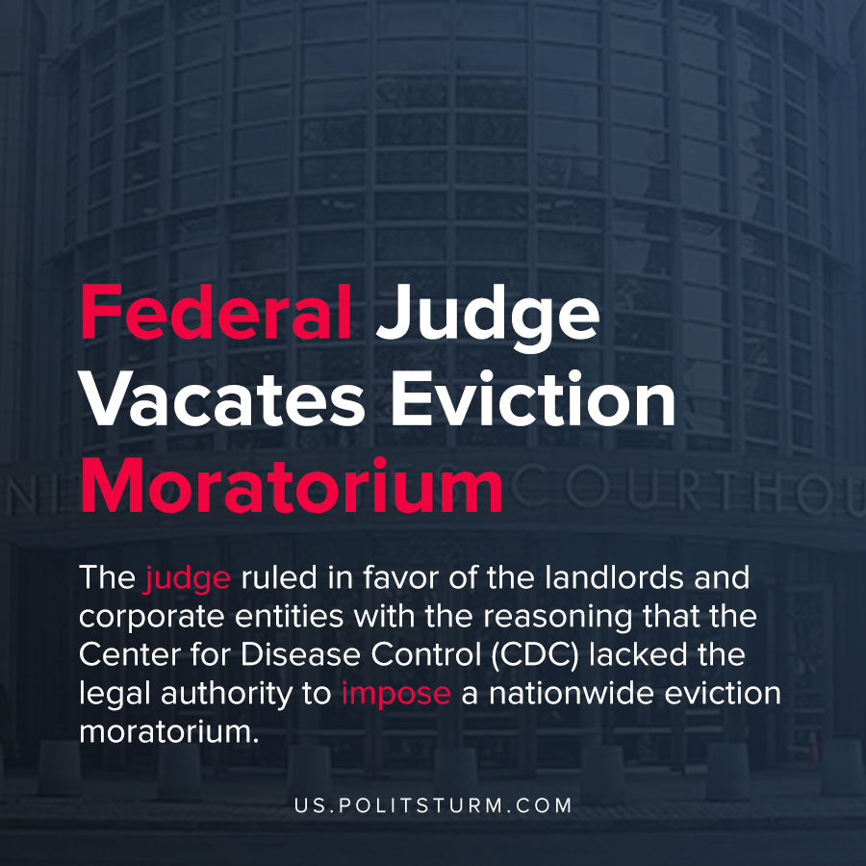

Original article
2021-05-14
1 min read

U.S. Federal District judge Dabney Friedrich ruled that the CDC overstepped its legal authority in prohibiting evictions through its eviction moratorium. As part of the Coronavirus Aid, Relief, and Economic Security (CARES) Act Congress enacted a 120 day eviction moratorium for rental properties receiving federal assistance.
After its expiration, a more broad eviction moratorium that applied to all rental properties was enacted which has been extended several times. The current order was set to expire on June 30th, 2021.
The plaintiffs in the case are Danny Fordham and Robert Gilstrap and the corporate entities that they use to manage rental properties. They were joined in challenging the legality of the order by two trade associations, the Alabama and Georgia Association of Realtors.
The judge ruled in favor of the landlords and corporate entities with the reasoning that the Center for Disease Control (CDC) lacked the legal authority to impose a nationwide eviction moratorium.

“It is the role of the political branches, and not the courts, to assess the merits of policy measures designed to combat the spread of disease, even during a global pandemic”, said the judge.
It is clear that the U.S. judiciary and legal system support the interests of the landlords and capitalists over and above the renters. While the eviction moratorium was implemented to limit the spread of the coronavirus during the exceptional pandemic conditions the landlords and their political associations are struggling for the ability to evict tenants who are behind on rent. This ruling is a modern example of the class struggle between the landlords and capitalists and the working class and demonstrates the extent to which modern political and legal institutions fully support the ruling class.
Source: 1

Original article

