Federal Judge Permits U.S. Agents To Use Excessive Force
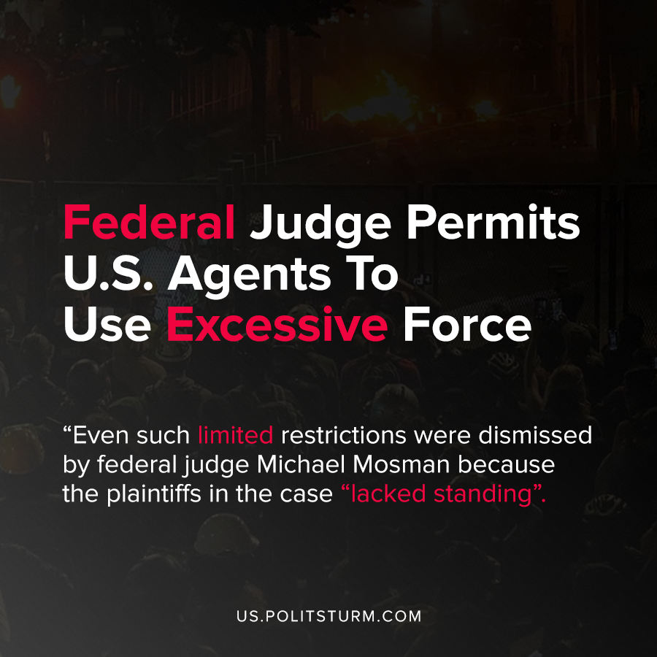

Original article
2020-07-25
1 min read

After federal agents have taken repressive actions against protesters and journalists in the city of Portland, the district court in Oregon approved a temporary restraining order. The temporary order, lasting 14 days, prevents federal agents from arresting journalists and using physical force without “probable cause”, among other restrictions.
Several journalists who brought the temporary restraining order were shot with tear-gas canisters, rubber bullets, and hit with batons while covering the protests. The journalists wore clearly marked vests and lettering to identify themselves as journalists.
Trump has supported sending federal agents to American cities including Portland in order to suppress protests and promote “law and order” in the wake of the killing of George Floyd.
Trump tweeted about the action, saying “We are trying to help Portland, not hurt it. Their leadership has, for months, lost control of the anarchists and agitators. They are missing in action. We must protect Federal property, AND OUR PEOPLE. These were not merely protesters, these are the real deal!”.
The Trump administration has used the protests as a pretext to increase the repressive force of the state against reporters and protesters. In this instance, the temporary restraining order limited the ability of federal agents to use repressive force within certain acceptable limits. Even such limited restrictions were dismissed by federal judge Michael Mosman because the plaintiffs in the case “lacked standing”.
However, there is no effective Marxist-Leninist organization in the United States that is able to limit the repression of the reactionaries represented by Trump. The protests themselves have not made any effective challenge to the rule of capital, and federal repression has increased. The state, as represented by the ruling of the federal courts, stands in lock step with the suppression of protesters and media espoused by the Trump reactionaries.
Any act of protest, even if it is not effective in combating the dictatorship of capital, will be vehemently denounced by the judiciary. Only a proper Marxist-Leninist understanding of the current events can lead the working class beyond ephemeral, disorganized protest and attack the ruling power of capital.

Sources: 1 , 2 , 3

Original article

