Fed Nominee Comments on Interest Rates
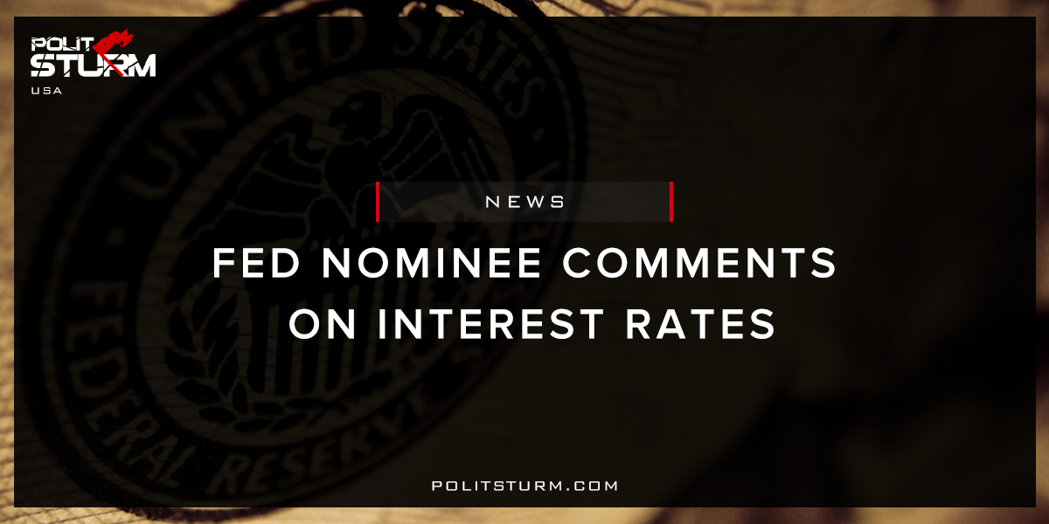

Original article
2017-11-29
2 min read

Federal Reserve chair nominee Jerome Powell said the case for raising interest rates at next month’s policy meeting is strengthening as the labor market improves without overheating the U.S. economy.
Powell was picked by President Donald Trump to replace Fed Chair Janet Yellen when her term ends in February. He spoke at his confirmation hearing in Washington before the Senate banking committee. The Fed will hold its final policy meeting of the year from Dec. 12-13.
“I think the case for raising interest rates at our next meeting is coming together,” Powell told Senator Dean Heller, a Nevada Republican. “Conditions are supportive of doing that.”
Politsturm: The new nominee for Federal Reserve chair Jerome Powell announced that the conditions are such that a continued rise in the federal interest rate is justified. This announcement should be music to the ears to the nation’s financial sector which reaps huge profits off interest payments. While the higher interest rates will be beneficial for financial capitalists, this is terrible news for industrial capitalists. Even within the capitalist class there are glaring contradictions with respect to economic incentives. A portion of the profit gained by an enterprise must be split between industrialists and financiers. The larger the split of unpaid labour that goes to the money-lending capitalists, the smaller the portion that the industrial capitalist receives.
At the peak of the industrial cycle there is an overproduction of commodities relative to the money supply necessary needed to circulate them. Just like in the last recession there will be a spike in the interest rates as the demand for money as a means of payment intensifies. Rather than signaling a robust economy which is “healthy”, rising interest rates signify that we are approaching the peak of the economic cycle. Bourgeois economists will claim that the economy is “heating up” or that economic conditions are “supportive” of rising interest rates. While these explanations may seem plausible at first glance they conceal much more than they elucidate. The fact of the matter is economists have not, are not, and will never predict any meaningful event that will occur in the global capitalist economy. At the time of crisis it is laid bare that these “professionals” are both literally and figuratively reactionaries.
Source

Original article

