On The Farmers' Protest Across Europe: Why Is This Happening and What Is The Solution?
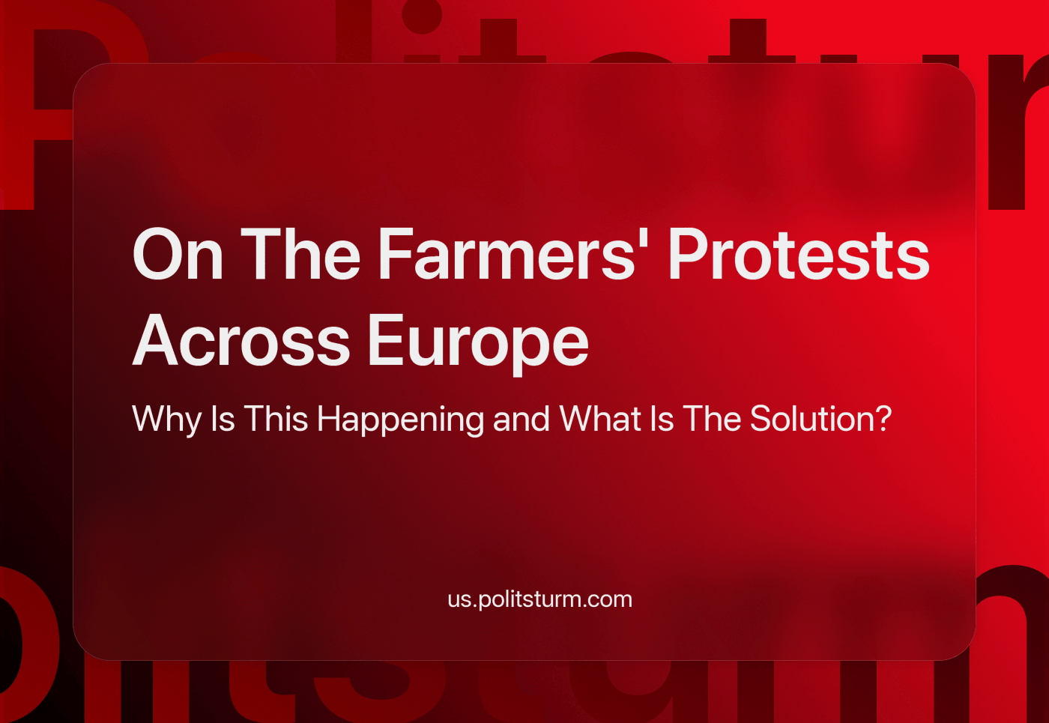

Original article
2024-03-26
7 min read

Since November 2023, there have been increasing protests by farmers in Europe, which have developed into a pan-European trend. In this article, we will try to understand the phenomenon of farmer protests and give a Marxist analysis of these events. We will not delve into the history of the issue in detail in each country, because this will add unnecessary details to the overall analysis of the situation.
We can note that while farmers have periodically protested before in Europe, however, specifically in this case, a series of events (crises, political reforms, ongoing green policies, etc.) have stirred up many contradictions.
As a result, we see protests with seemingly fair demands and slogans. Despite the inconveniences caused during the blockade of streets and roads, farmer protests enjoy mainly national support [1] (Germans support German farmers, French support French farmers, etc.)

The reasons for the protests

1. The common reason for the protests is falling profits.
Farmers' costs have increased. This was especially true for the prices of electricity, fertilizers and transport. At the same time, Europeans have fully felt the cost-of-living crisis, and in order to somehow soften the blow, the authorities and retail entrepreneurs have taken measures to curb the rise in food prices. As a result, farmers began to receive 9% less for their goods than before (comparing the third quarter of 2023 with the same period of 2022).
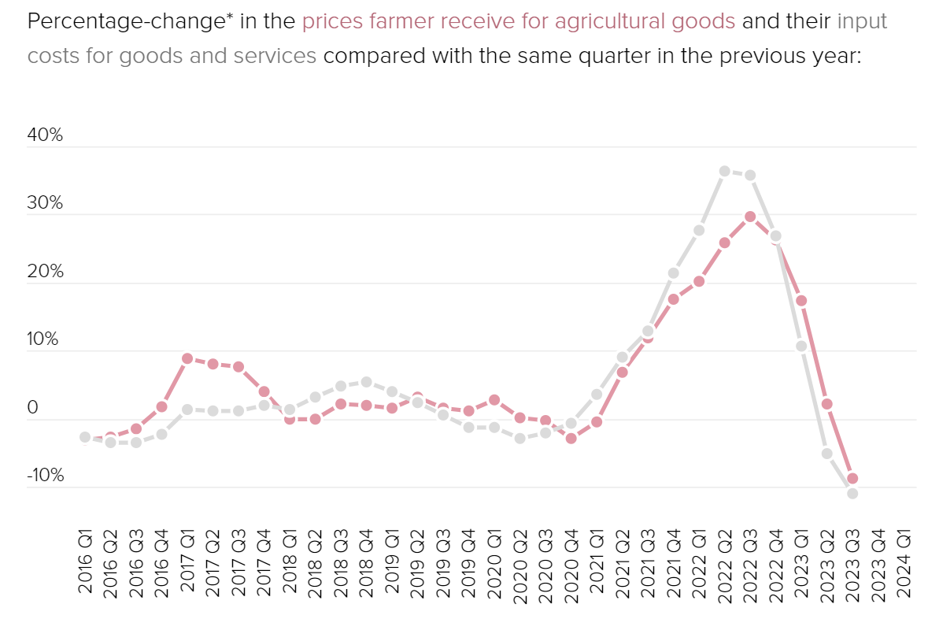
Source: https://www.politico.eu/article/farmer-protest-europe-map-france-siege-paris-germany-poland/
This is evidenced by Eurostat data analyzed by Politico [2]. Only a few products like olive oil have not been affected by this trend.
Brussels has already decided who and what to blame for what is happening. "Farmers are the first to feel the effects of climate change. Droughts and floods destroy crops and livestock. In addition, farmers are feeling the effects of the conflict in Ukraine: this is inflation, the rising cost of energy, fertilizers ...", — said the head of the European Commission, Ursula von der Leyen on February 6, speaking to MEPs [3].
In fact, it is not so much nature and Russia that should be blamed for the rise in price, as the capitalist system as such. Only in a society where the main goal of all production is to make a profit will there be objective contradictions between the producer and the consumer. The manufacturer wants to sell at a higher price, while the consumer wants to buy cheaper. But the consumer does not have the state, the army and other management and control tools, but the manufacturers do. As a result, we have a society where any crisis hits the working class the hardest, while at the same moment, the biggest capitalists are having a feast during the plague.

2. Eastern Europe
In Eastern Europe, a fairly obvious source of the problem is the influx of cheap goods from Ukraine.
The root cause of this was the agreement of Ukraine on association and partnership with the EU, according to which Ukraine could import duty-free certain goods into the EU under quotas - wheat, sunflower, corn and the like. But when the conflict with Russia began, the EU removed these quotas. Ukraine could import as much grain, and as many raw materials as it was able to export.[4]
As a result, the scheme started working differently than it was originally intended: the bulk of grain began to settle in the EU countries near Ukraine, which caused a crisis of agricultural overproduction there.
Farmers began to suffer serious losses, hence these protests appeared when they began to block the borders in order to keep Ukrainian trucks out.

3. Western Europe
Western European farmers are more affected by the influx of cheap agricultural products from the south.
The protests in France or Germany are of a slightly different nature, and it was not Ukrainian agricultural products that posed a threat to them. They were more concerned about the supply of cheaper products from southern European countries — Spain, Portugal, Greece, Italy, which is also cheaper. This affected the income of local producers.
This is one of the problems of the EU's internal market. There are no borders inside, there are no customs duties and charges. One can produce products anywhere and sell them wherever it is profitable.
There are certain standards and requirements in the European Union that all manufacturers are required to comply with. Accordingly, market mechanisms direct capital along the most profitable path - to cheap labor. It is cheaper to produce, and more expensive to sell.

4. Pan-European farmers' dissatisfaction with green policy
The green policy of unification has also become a serious burden for EU farmers. The agricultural sector is particularly concerned about measures within the framework of the "Farm to Fork" strategy [5]. It is positioned by the European authorities as a way to create an environmentally friendly healthy food system in the EU. At the same time, Brussels hopes to achieve carbon neutrality by 2050 thanks to the measures provided for it. This strategy includes, among other things, the following requirements for farmers:
- Reducing the use of pesticides by 50% by 2030, and fertilizers by 20%;
- Release of land for non-agricultural use (for example, by planting trees);
- The transfer of 25% of all EU agricultural land for the cultivation of organic products.
The protesting farmers do not consider the goals set by the EU realistic, noting the inviability of its green policy, which, in their opinion, leads only to the destruction of their industry. [6]

5. Agreements on the import of products that do not meet all European requirements in advance, but are much cheaper.
The problem arising from the previous paragraph is: why does Europe need expensive agricultural products if capitalists can import cheaper ones?
Farmers in Spain, Portugal and France are concerned about the consequences of the upcoming EU free trade agreement with MERCOSUR countries (Brazil, Argentina, Uruguay, Paraguay). European farmers believe that it is fraught with new problems for the European agricultural sector since Brussels does not put forward the same standards as in the domestic market regarding the products of Latin American suppliers. [7]
At the same time, there is no unity in Europe on this issue, because this agreement itself is needed to compete with China in Latin America. The MERCOSUR free trade zone is expected to affect 750 million people or about 20% of the global economy.[8]

6. The logistical crisis in the Red Sea
Some publications highlight the crisis in the Red Sea as a cause, where the Houthis threaten ships suspected of shipping to Israel. Because of this, the entire flow of global goods has suffered, including European products, which now need to be transported for 15-20 days longer. This significantly increases the cost of transportation and forces some of the goods to remain in Europe, unintentionally leading to them dumping these goods in their own market and forcing small farmers to incur losses. [9]
Summing up the reasons, we can say that European populism, the crises of capitalism and the pursuit of profit have brought the European agricultural sector to a dead end, the way out of which is the import of cheap products to maintain profit margins. There is not enough political will to abandon populist ideas, because for how many years in a row the values of the green agenda have been planted in the European Union, abandoning them is political suicide for the current politicians in power.
European farmers are dissatisfied because only the large agro-industrial monopolies capable of transforming production with technology, and machinery and incurring other costs associated with reforms will be able to objectively meet all EU requirements by 2030 and beyond.
The objective interest of the petty bourgeoisie (farmers are exactly that) is to preserve one's existence as a smallholder and not to slip into a proletarian existence.
The contradiction here is the very existence of the petty bourgeoisie, which wants to exist and develop in the era of imperialism, the era of monopolies and large multinational companies.

Is there a cure for this disease?
A large-scale environmental plan (perhaps Ursula von der Leyen's key project) suggests that by 2050 Europe should become the first carbon-neutral continent (that is, the use of green technologies and various initiatives will offset the negative impact of greenhouse gases on the climate). Moreover, just in early February, at the height of the farmer protests, the European Commission unveiled a plan according to which by 2040 greenhouse gas emissions in Europe would be reduced by 90% compared to 1990 levels. According to Politico, initially, the draft document stated that emissions produced by agriculture should be reduced by 30% between 2015 and 2040. However, the final version does not contain this phrase: it only mentions that "all sectors" (as well as ordinary Europeans who need to reconsider their eating habits and lifestyle) should contribute to the common cause. [10]
Nevertheless, it is obvious that the set goals will not be achieved without major changes in agriculture, which accounts for 11% of greenhouse gas emissions in the EU. And how to achieve changes and not ruin farmers (mostly small businesses with limited finances and equally limited opportunities to adapt to new requirements) is a question that bourgeois politicians have no answer to.
The Communists do not support the petty bourgeoisie in Europe, but their protests are an indicator of the growing contradictions of capitalism. If there are workers' parties that are part of an international association, at least at the European level, it would be possible to discuss an alliance between the farmers and the workers, which would be possible on the basis of the farmers abandoning their present interest in favour of their future interest. Then it would be possible to talk of how farmer protests could be turned to the benefit of the working class. But in their absence, these protests are essentially reactionary, their main goal is to preserve their semi-bourgeois position and for them not to completely slip into the ranks of the proletariat. At the same time, the course of history itself shows us that the ever-rising concentration of production is inevitable. It is reactionary to fight against agro-industrial monopolies with the goal of maintaining small-scale production.
The capitalist system is unable to solve many modern problems, including poverty, overproduction crises, and even more so the rational use of natural resources, because, under capitalism, profit is the main goal, not the populist promises of European politicians. Politicians come and go with their promises, but monopolies continue to make profits.
There is a cure for this disease - it is socialism. Only under socialism will it be possible to transform the way of production and make agriculture one of the most technologically advanced industries. To make carbon-neutral not just a promise for one continent, but a reality for the entire planet. But this requires an organized struggle of the working class for its own interests.
Sources: 1,2,3,4,5,6,7,8,9,10

Original article

