Fake Priest Hired to Incriminate Workers in Religious Confession
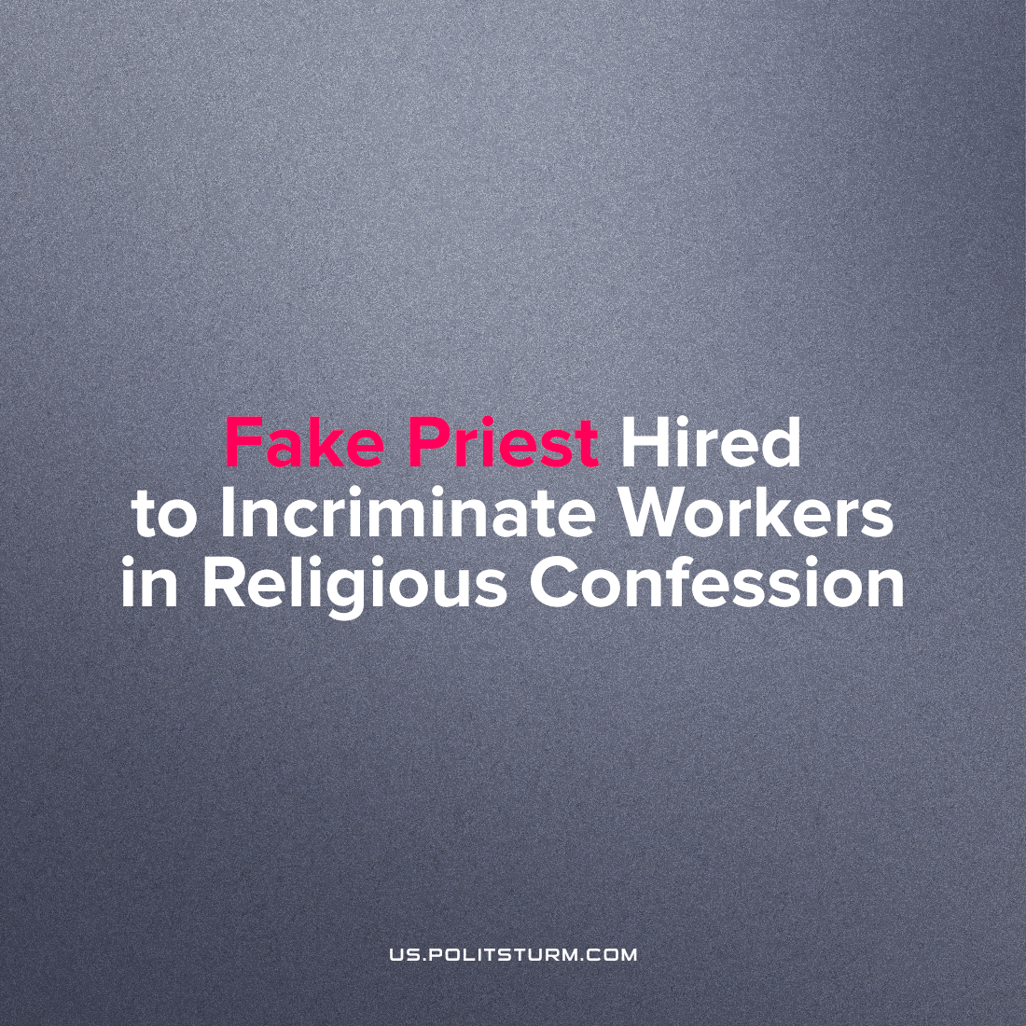

Original article
2023-07-13
1 min read

According to CBS, a restaurant chain in California used the services of a fake priest to use the Christian practice of confession of sins in a ruse to extract information about whether an employee had acted against the interests of the company.
By the time the priest was hired, the restaurant owner already owed about $140,000 in back wages they owed their employees. In addition, the company was not paying overtime hours and was threatening employees.
Apparently, the California restaurant chain is trying to catch employees in the wrongdoing and minimize the portion of their compensation that they receive. What are the objective reasons?
The first is that human labor creates enormous value and wealth, and that business owners and employers only privately appropriate that labor. The second reason is the pursuit of profit in the face of fierce capitalist competition. These two circumstances put business owners in a position where they must necessarily increase their profits, and to do so they must infringe upon their workers in every way possible. This is the invariable logic of any private business, and every business operates according to this principle.
Often employers use fraud, forgery and intimidation against employees, or even committing open crimes to achieve their goal. This case shows exactly the stupefying power of religion which is used to attack workers, weaken their resistance to capitalist exploitation, inspiring Marx to name it the "opium of the masses".
Source: 1

Original article

