Every Tenth Child in the World is Forced to Work for Food
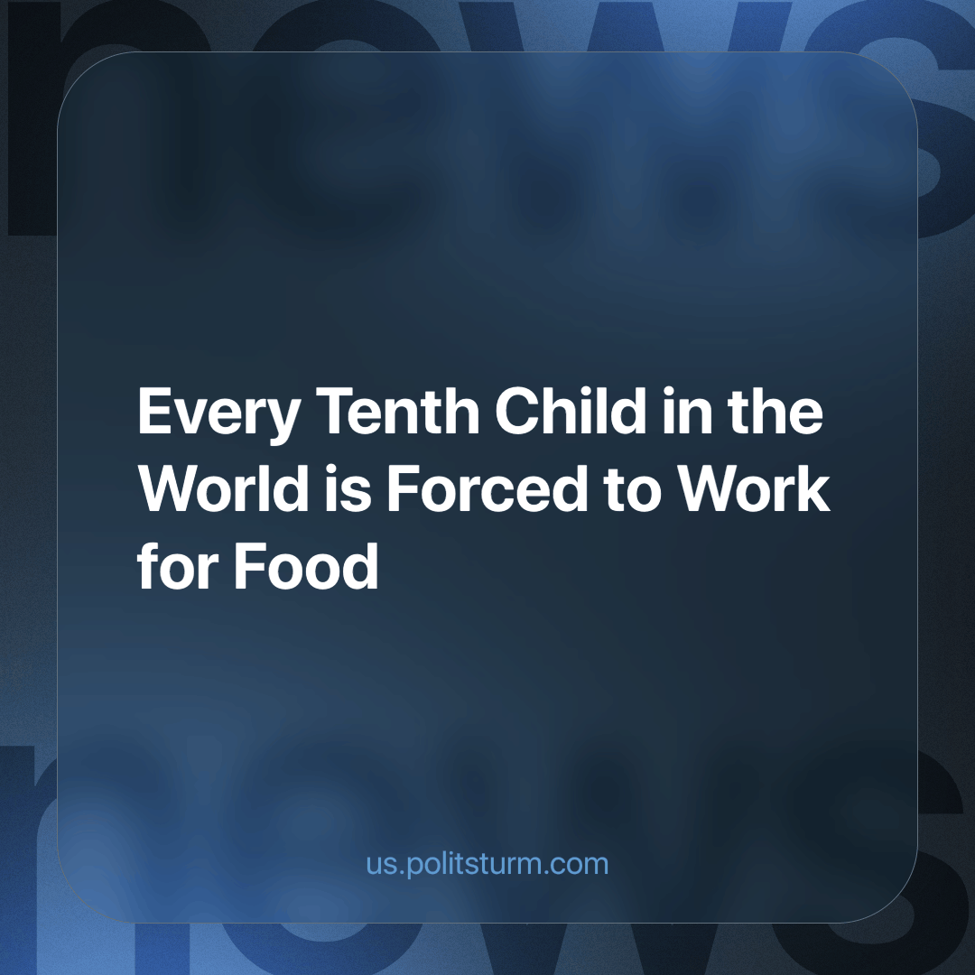

Original article
2023-12-30
3 min read

According to the ILO and UNICEF, there are 160 million working children worldwide. Nearly 87 million are in Sub-Saharan Africa, and about 61 million are in North Africa and the Asia-Pacific region.
In 1989, the UN adopted the Convention on the Rights of the Child, which prohibits child labour under the age of 14. Article 32 is supposed to protect children from exploitation. In practice, the situation is different, and the COVID-19 pandemic has only exacerbated the problem. In poor countries, family incomes dropped during quarantine, and remote education was not affordable. As a result, children's free time became occupied by work.
"During a crisis, child labour becomes a mechanism of survival for many families. As poverty grows, schools close, and social services become less accessible, more and more children are forced to work," explained UNICEF Executive Director Henrietta Fore.
Statistics show that 112 million children work in agriculture, 31.4 million in services, and 16.5 million in industry. This doesn't include the domestic labour of girls from poor families, which, according to experts, can take up to 20 hours per week. Most working children are under 11 years old.
For example, India has the highest incidence of child labour in gold mining, cocoa harvesting, and clothing production. According to the UN, many child workers in India are not even 9 years old. It's worth noting that India ratified the Convention on Child Labour, but that doesn't necessarily mean that the country complies. Many residents migrate to large cities without documents, so their age may not raise questions.
In another country, Bangladesh, 33 million children under 18, according to UNICEF, live below the international poverty line — they live on less than $1 per person per day. Statistics show that half of these children drop out of school after elementary classes and work in fields and factories for 12 hours a day, earning just over $1.5 daily. Every 12th worker in the country is a minor.
Interestingly, the G20 countries are determined to eliminate child labour in the value chains of goods and even adopted a corresponding declaration this year. However, the US seems to be heading in the opposite direction. The state of Iowa passed a bill in the Senate that lifted restrictions on child labour, expanding the types of employment and the length of shifts, including night shifts. According to the Economic Policy Institute (EPI), similar initiatives have been considered in ten states over the past two years.
Cases of child labour are also being uncovered in the US, such as dozens of children under 12 working in a car parts factory in Alabama and hundreds engaged in hazardous work at a meatpacking plant in Wisconsin. These are mostly migrant children trying to survive in a foreign country.
In conclusion, it can be inferred that large companies are not ashamed to exploit child labour. Owners of the means of production are not concerned that many children are effectively deprived of childhood and proper education, as they are forced to spend whole days working in factories, farms, plantations, etc.
Instead of addressing this issue, entrepreneurs often claim that by hiring minors, they are "teaching children about adult life" and educating them about "the value of money," among other things. In reality, behind these beautiful phrases lies the desire of companies to use cheap labour in enormous quantities.
The low wages of family breadwinners force not only their wives but also their children to engage in labour. In the end, those who work diligently and essentially perform the bulk of the work receive "pennies," while their employers reap enormous profits. Only a transition to socialism, eliminating all exploitation of one person by another and transferring all means of production from private hands to public ownership, can fundamentally change the workers' situation.
Source: AMMIAC Information Agency - "Not Toys: Why Every 10th Child in the World Works for Food" dated November 22, 2023.

Original article

