Every Fifth Resident in Russia Has Experienced Homelessness
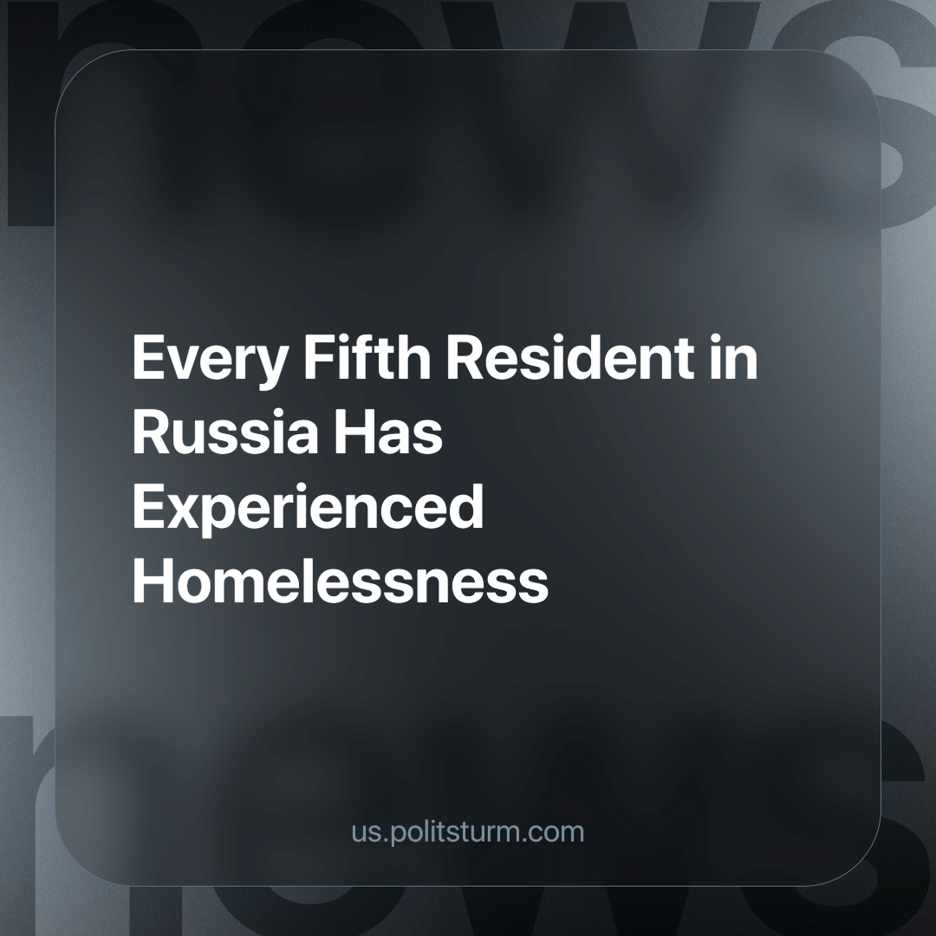

Original article
2023-12-26
1 min read

The organization "Night Shelter" reports that one-fifth of Russians have encountered housing challenges, forcing them to seek refuge with friends or in hostels due to a lack of stable alternatives. Moreover, a significant percentage has resorted to sleeping in emergency housing or unsuitable places. Among these individuals, approximately one-third grapple with substantial difficulties in covering their housing expenses.
Survey respondents stated that government authorities should assume responsibility for addressing this issue, yet many remain unaware of the state's actions. The government, primarily focused on the interests of oligarchs, appears preoccupied with reforms and key rate adjustments, neglecting the urgent needs of workers struggling with housing, food, and leisure expenses.
A socialist state consistently works to fulfil the fundamental needs of its people, ensuring secure employment, education, housing, and other absolute essentials. This stands in stark contrast to the capitalist state, which merely prioritises those who control capital, leaving workers by the wayside to struggle with everyday life. The establishment of a socialist state is the only true solution to addressing such issues.
Source: Forbes - "Every Fifth Resident in Russia Has Experienced Homelessness" dated November 20, 2023.

Original article

