Ever-increasing Debt Starts Threatening The Capitalists
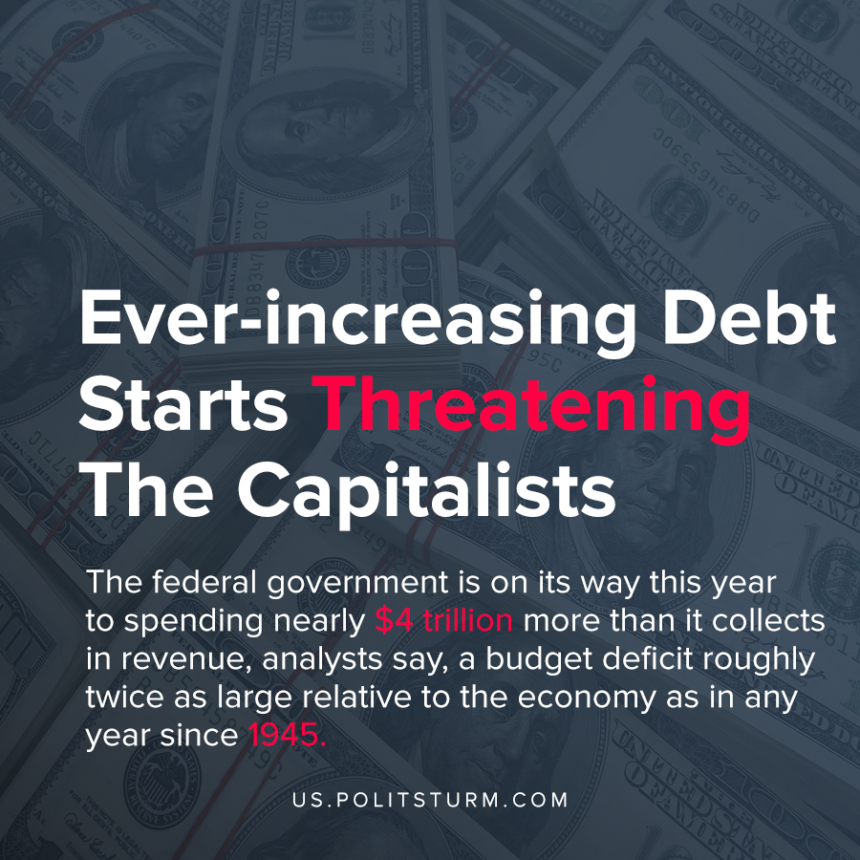

Original article
2020-04-23
1 min read

The federal government is on its way this year to spending nearly $4 trillion more than it collects in revenue, analysts say, a budget deficit roughly twice as large relative to the economy as in any year since 1945.
“We should be very worried,” said Atif Mian, an economics professor at Princeton University who has written widely on the subject. “We are talking about a level of debt that would certainly be unprecedented in modern history or in history, period. We are definitely at a tipping point.”
From this news, we see that the federal debt can be stretched for so long until it will all collapse and these are signs of us being in late-stage capitalism, as the same had occurred during the great depression, whereupon public debt reaching its peak, it would freeze and worsen the consequences of the overproduction crisis. However today it will not create governments that would act during the great depression, following Keynesian models while fascisticaly putting down worker movements. Today we can only face fascist government, as social democracy cannot exist due to the falling rates of profits.
Since USA is one of of the international banker countries, seeing one of these pillars fall will lead to even worse consequences than the great depression, however it was unavoidable since it is an inherent aspect of capitalism, and no reform will ever fix it. Only socialism is capable of fixing capitalism by destroying it and creating a world where there is no unemployment, no fictitious capital, no private accumulation of wealth. And there are no needs for good words, as historically no socialist country had ever experienced a crisis of overproduction, USSR flourished when the capitalist countries were devoured by the system itself, by its own contradictions.
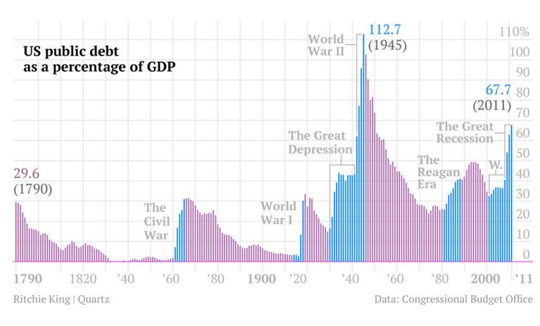

Original article

