European States That Planned to Sanction Israel Supported Strikes on Iran
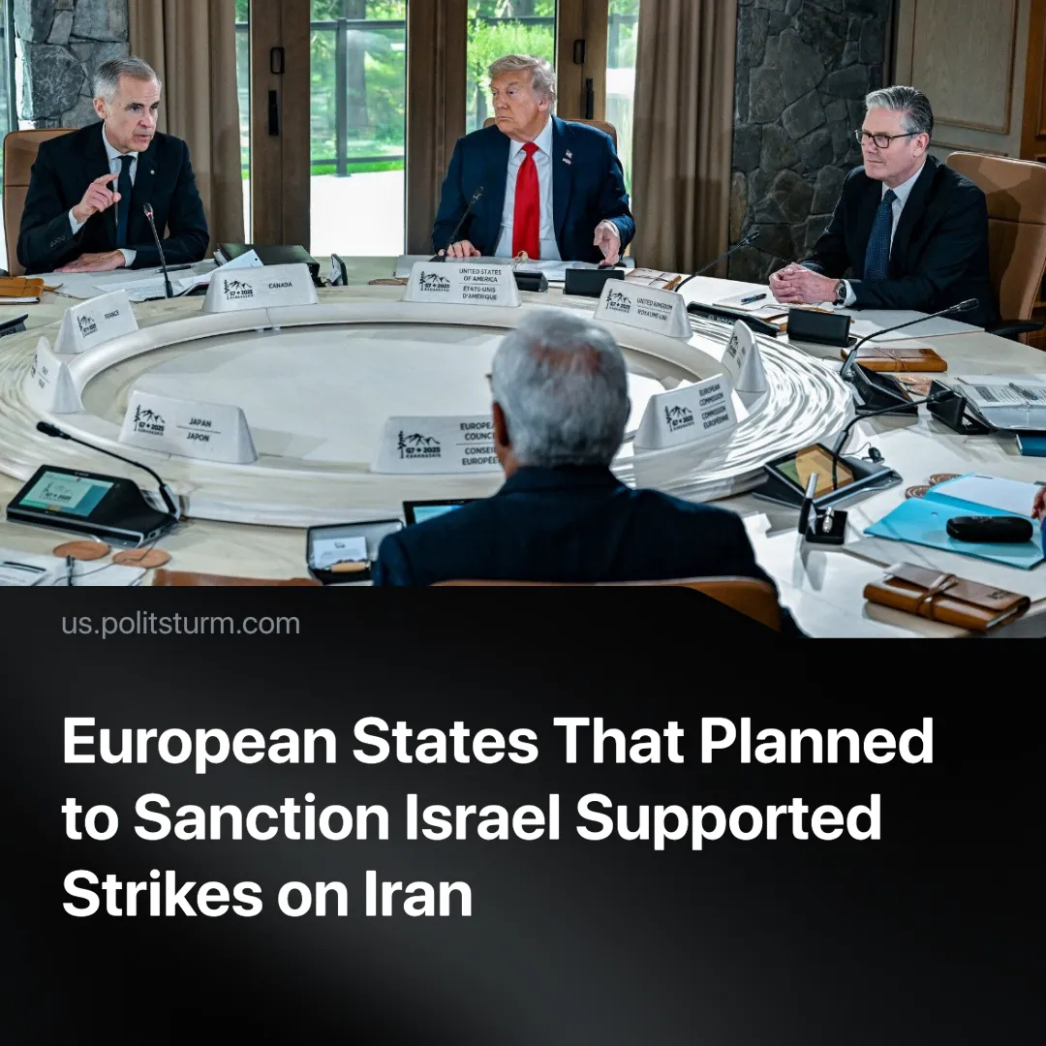

Original article
2025-06-24
1 min read

EU countries unanimously supported Israel during the conflict with Iran. Before that, the European Union planned to impose sanctions on Israel because of Gaza.
Details. After Israel began its supposedly preventative attack on Iran, G7 leaders jointly reaffirmed Israel’s “right to self-defence” and labelled Iran the “main source of instability” in the region.
► During the G7 summit, German Chancellor Friedrich Merz openly praised Israel’s strikes on Iran, declaring that Israel was “doing the dirty work for all of us” by weakening Tehran’s nuclear capabilities.
► The British finance minister publicly signalled possible military support for Israel in the Iran conflict.
Context. Western powers previously condemned Russia’s so-called “Special Military Operation” in Ukraine, which Russia claimed was preventative. Russia’s operation was labelled “unprovoked and unjustified” and claimed that it undermined “European and global security and stability.
► Now, Israel similarly says its attacks on Iran are preventative. Yet, it is met with open support from these same Western powers, who themselves have also previously invaded Iraq under similar pretences.
► No G7 leader raised concerns over Israel’s repeated violations of Syrian and Lebanese sovereignty in the months leading up to the summit.
► European calls to recognise Palestine emerged only after tensions with the U.S. heightened, but were dropped once siding with Israel became politically convenient.
► This double standard is a reflection of the interests of each country’s capitalists. Law and morality aren’t unchanging, but rather are constantly adapted and moulded to fit each situation.

Original article

