Europe to Increase Military Spending as Relations with US Worsen
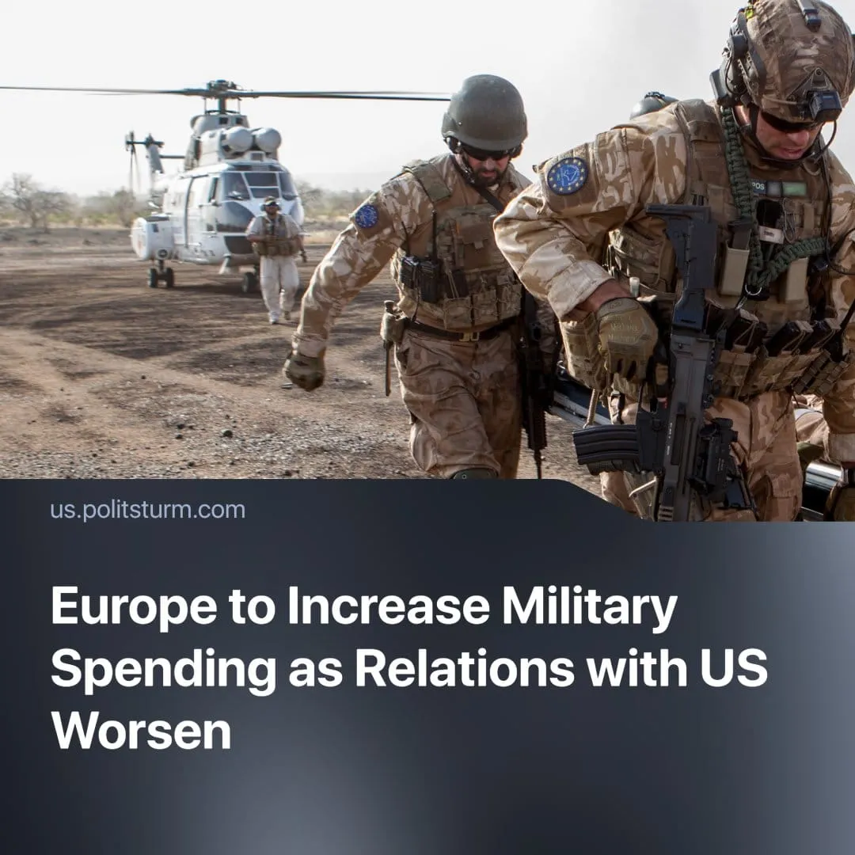

Original article
2025-03-10
2 min read

The President of the European Commission, Ursula von der Leyen, has unveiled a plan to "rearm Europe" that could increase the bloc's military spending by nearly €800 billion ($863 billion).
Details. The EU is set to significantly increase military spending and bolster its defences through a five-step plan that incorporates various economic measures, following the United States' decision to halt military aid to Ukraine and after statements from Trump such as “If they don’t pay, I’m not going to defend them”, when referring to Nato allies.
► The five-step plan includes measures such as suspending strict budget rules, facilitating loans for defence spending, shifting resources to military spending and mobilising more private capital.
► In addition, a meeting of European leaders in Brussels on 6 March 2025 reaffirmed their intention to support Ukraine, with France saying it could extend its nuclear deterrent to protect the continent from Russian threats and the British Prime Minister announcing a "coalition of the willing" to seek peace in Ukraine with US support.
Context. The US’s deal to gain access to 50% of Ukraine’s mineral resources fell apart in a dramatic televised argument between the countries’ leaders. This event led the US to suspend military aid to Ukraine — although both countries have now expressed an interest in resuming talks.
► Historically, Europe has relied on the US and NATO for protection. However recent events have convinced EU leaders that they are unprepared militarily for the growing threat of direct conflict between capitalist powers.
► Under Trump's second presidency, the US has adopted a different strategic policy than the Democrats, attempting to force concessions from rival powers and former allies by imposing tariffs and cutting foreign aid.
► The EU has increased its military spending over the last several years. Going from €214 billion in 2021 to €326 billion in 2024.
Important to know. This more assertive attitude of the USA towards its “allies” and the increasing militarisation of Europe reflects the growing tensions between different imperialist blocs as they draw lines to compete for the redivision of the world, possibly leading to another world war.
► The EU's imperialist ambitions for its own slice in the coming re-division of the world are hidden behind the denunciation of Putin as a conquering dictator or behind the claim that the USA has abandoned Europe. In this way, the leaders of the EU justify their increasing militarisation.
► Simultaneously, leaders like British Prime Minister Sir Keir Starmer attempt to maintain good relations with the U.S. and Europe. He says, for example, that "there must be a US backstop" for any peace deal in Ukraine. In doing so, he seems to be accepting a position of semi-dependence to the US for British capital, while the EU attempts to chart its own course.
► The context of war preparation has also historically been used to repress working-class movements, increase their exploitation and repeal liberal-democratic rights in the name of "national security" or “defence”.
Conclusion. The "Rearm Europe" proposal is a dramatic but predictable escalation of the European Union amidst the increasingly fierce competition between different capitalist powers to either protect their sphere of influence or grab a bigger piece of the cake. This is a natural consequence of the imperialist stage of capitalism. A numerically small number of capitalists actively prepare for war and are willing to engage in it if deemed profitable, while the ones who will have to pay for this are the workers of all nations. The only solution is to replace the profit-driven capitalist system with the worker-led system of socialism.

Original article

