EU Labor Laws to be Dissolved in the UK
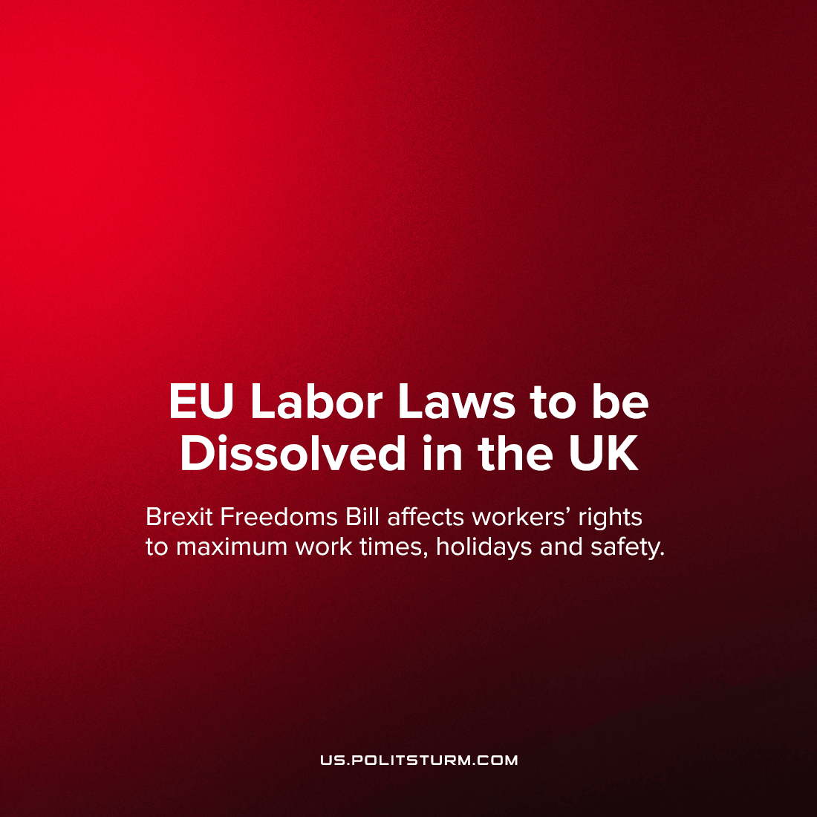

Original article
2023-01-15
1 min read

By the end of 2023, and in some cases 2026 all retained EU law in Britain will expire due to the “Brexit Freedoms Bill”. This could include things like the laws regarding the guaranteed limits on working hours, minimum paid holidays, and other workers’ rights as well as laws regarding safety and quality standards. Previously when Britain was in the EU, European law took precedence over British Law but now that Britain is no longer in the EU, the government has until the end of the year in most cases to write equivalent British laws guaranteeing these things.
This aptly named bill demonstrates the paucity of freedoms under capitalism; and how what freedom really means for capitalists is the freedom to exploit. While Brexit unshackled the UK from EU imperialism, freeing the country from EU enforced privatisation, anti-union and anti-democratic judgements from the European Court of Justice, increased European militarism, EU restrictions on public ownership etc., the ruling class of Britain have done this not to move the country away from these things, but to attempt to push them further than the rest of the EU.
While Britain remains under the dictatorship of capital (whether in the EU or not), laws like the right to paid holiday and limits on working hours are in the hands of the bourgeoisie and can be retained or discarded according to their fancy, and that only by independently exercising their power as a class and ultimately taking power as a class can the workers permanently guarantee their rights and livelihoods.
Source: 1, 2

Original article

