EU Condemns Israel’s War to Expand Its Own Imperialist Reach
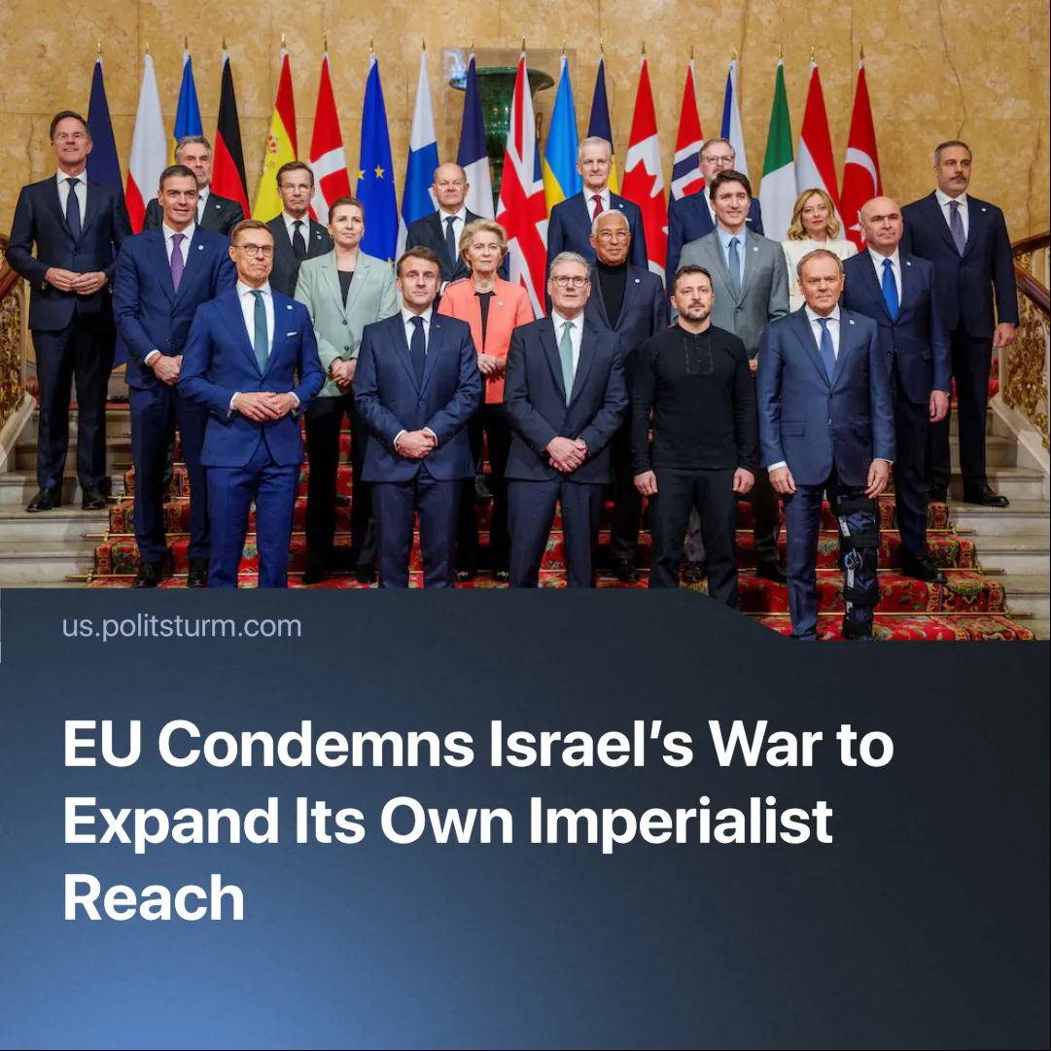

Original article
2025-05-31
2 min read

Formerly staunch supporters of Israel’s offensive in Gaza across Europe are now condemning it. This is not out of concern for Palestinians, but in pursuit of their own imperialist goals.
Details. The EU will review its trading partnership with Israel after the majority voted in favour of the claim that Israel violated Article 2 of the trade agreement. This article states that the relationship is "based on respect for human rights and democratic principles."
► The UK, France, and Canada have published a joint statement strongly condemning the renewed offensive against Gaza. The three countries have warned that they will take concrete action in response to the situation if steps are not taken to mitigate the suffering of the population.
► The UK has suspended trade talks with Israel and imposed sanctions on "extremist West Bank settlers" — Canada and France have also threatened sanctions.
► The three countries have expressed support for the efforts of the United States, Qatar, and Egypt to achieve a ceasefire. They believe that a ceasefire is the best way to secure the release of hostages, minimise suffering in Gaza, and achieve a two-state solution.
►French President Macron has called for Europe to “harden the collective position” on Israel, “not only as a moral duty, but a political necessity.”
Context. EU relations with the United States have drastically deteriorated during the trade war. Since then, the bloc has been moving towards consolidating itself as a separate and independent power.
► Netanyahu is allowing very limited aid to flow into certain areas of the Strip via the US-backed Gaza Humanitarian Foundation (GHF), while still preventing access for UN aid — a move criticised by top EU diplomat Kaja Kallas.
► This came alongside Operation "Gideon's Chariots", which, according to Israeli officials, would see them "conquer" Gaza, destroy its buildings, and relocate Palestinians from the north of the Strip to the south.
► Germany — the EU’s most dominant state — is the second largest arms supplier to Israel, supplying a total of $326.5 million worth in 2023 — 30% of Israel’s military equipment. But German Chancellor Friedrich Merz has promised the country would take a leading role within the EU. Aligning with the bloc’s imperialist interests, Merz has also moved to condemn the Israeli offensive.
► Public support for Palestinians has not decreased — tens of thousands of people have taken to the streets to protest against Israel’s campaign.
Important to Know. The sudden change in government officials' stance on the Gaza conflict does not mean that they are morally opposed to Israel's actions. Western countries have defended Israel's campaign in the past, even as it killed tens of thousands of civilians — official figures report that the death toll has surpassed 54,000.
►The EU is attempting to carve out its own spheres of influence to compete with the US and China. A ceasefire would allow the bloc to support a Palestinian state and strengthen its position in the highly contested Middle East. By weakening Israel’s position, the EU could also undermine US power and disrupt China’s trade in the region.
►This shows the outcome of non-communist leadership in both Palestine and domestic EU pro-Palestine movements. The domestic European population’s outrage is being channelled into support for their own nation-states as they begin to oppose Israel's actions. At the same time, a future Palestinian state is left vulnerable to exploitation and dependency on larger imperialist powers.

Original article

