Essential Workers Earn 18% Less Than National Average
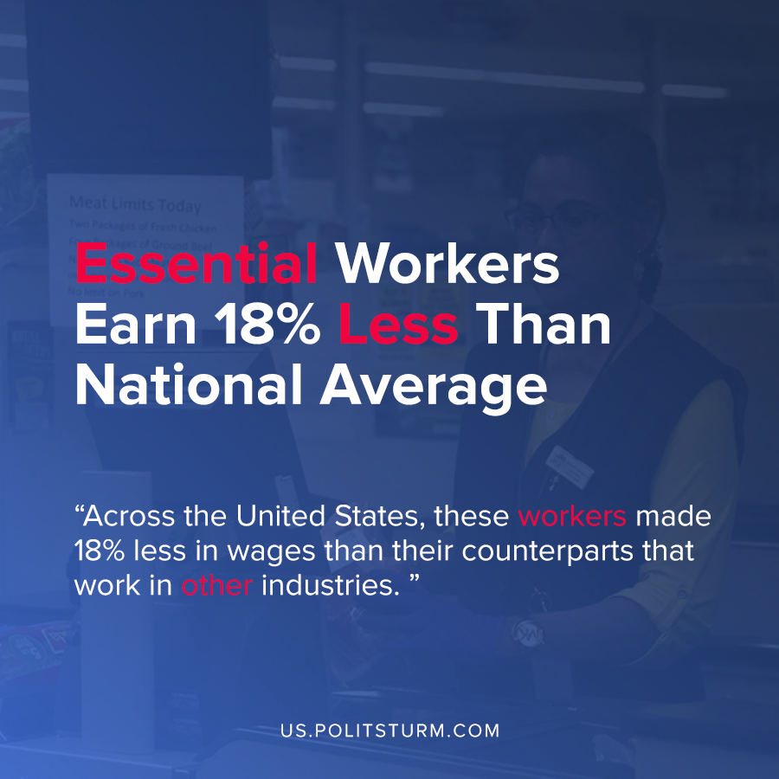

Original article
2020-07-22
1 min read

With the coronavirus pandemic, a great deal of attention has been paid to workers whose jobs are essential to the functioning of society. Despite the rhetorical praise given to essential workers, a recent study unsurprisingly found that they are among the lowest paid workers.
The study examined the salary data from the Bureau of Labor Statistics for retail salespeople, postal mail carriers, light truck drivers, cashiers, janitors, and cleaners and compared them to the average salary in each respective state.
Across the United States, these workers made 18% less in wages than their counterparts that work in other industries. The District of Columbia had the highest disparity with a 48% difference in wages between the examined essential workers and the average wage.
Despite the rhetorical praise they receive, the fact is that these workers are paid objectively lower wages and face greater risk of exposure to COVID-19.
The capitalist economic system, which strives to maximize profit for the private owners of land and capital, ruthlessly exploits the workers for their benefit even during the pandemic. During this pandemic, the lowest wage workers face the most difficult circumstances for the lowest level of compensation. Only a socialist system run in the interests of the working class will be able to change this absurd situation and provide these workers the protection and pay that they deserve.
Sources : 1 , 2

Original article

