Engels on Workers' Party
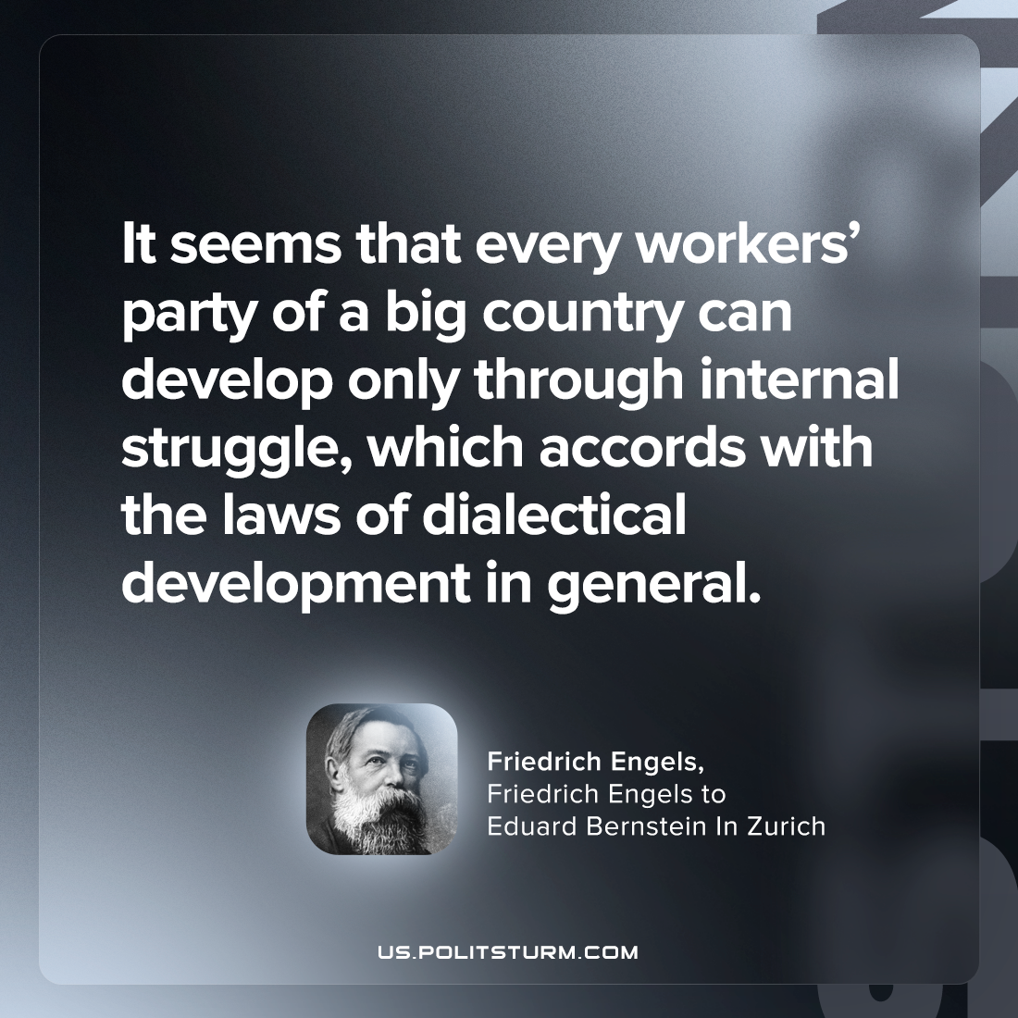

Original article
2023-05-23

"It seems that every workers’ party of a big country can develop only through internal struggle, which accords with the laws of dialectical development in general."
Friedrich Engels, "Friedrich Engels to Eduard Bernstein In Zurich"

Original article

