Engels on the Trend towards a Socialist Revolution
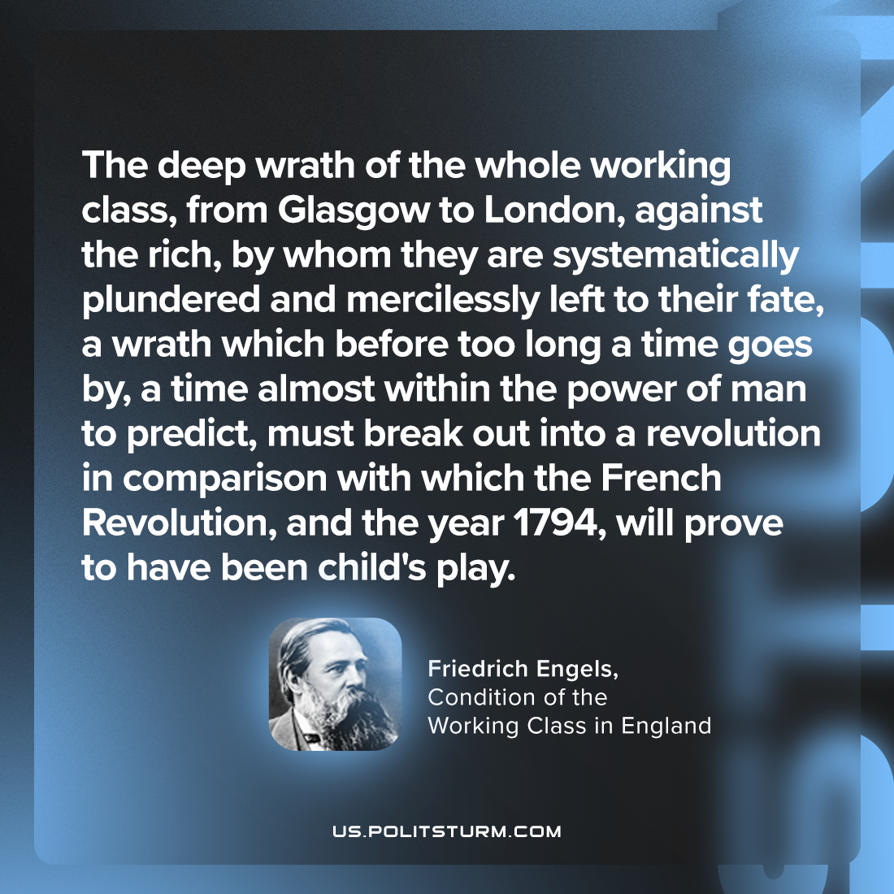

Original article
2024-03-16

“Hence also the deep wrath of the whole working-class, from Glasgow to London, against the rich, by whom they are systematically plundered and mercilessly left to their fate, a wrath which before too long a time goes by, a time almost within the power of man to predict, must break out into a revolution in comparison with which the French Revolution, and the year 1794, will prove to have been child's play.”
Friedrich Engels, Condition of the Working Class in England

Original article

