Engels on The Struggle
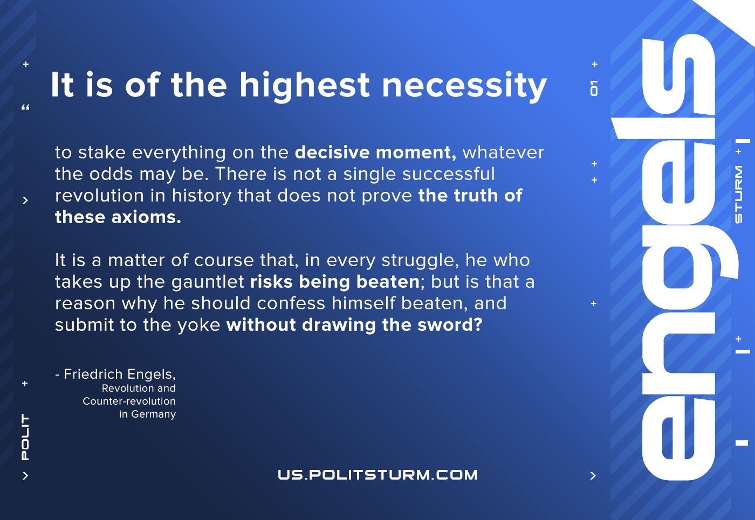

Original article
2020-12-08

It is of the highest necessity to stake everything on the decisive moment, whatever the odds may be. There is not a single successful revolution in history that does not prove the truth of these axioms.
It is a matter of course that, in every struggle, he who takes up the gauntlet risks being beaten; but is that a reason why he should confess himself beaten, and submit to the yoke without drawing the sword?
F.Engels, Revolution and Counter-revolution in Germany

Original article

