Engels on the Struggle of Workers and Revolution
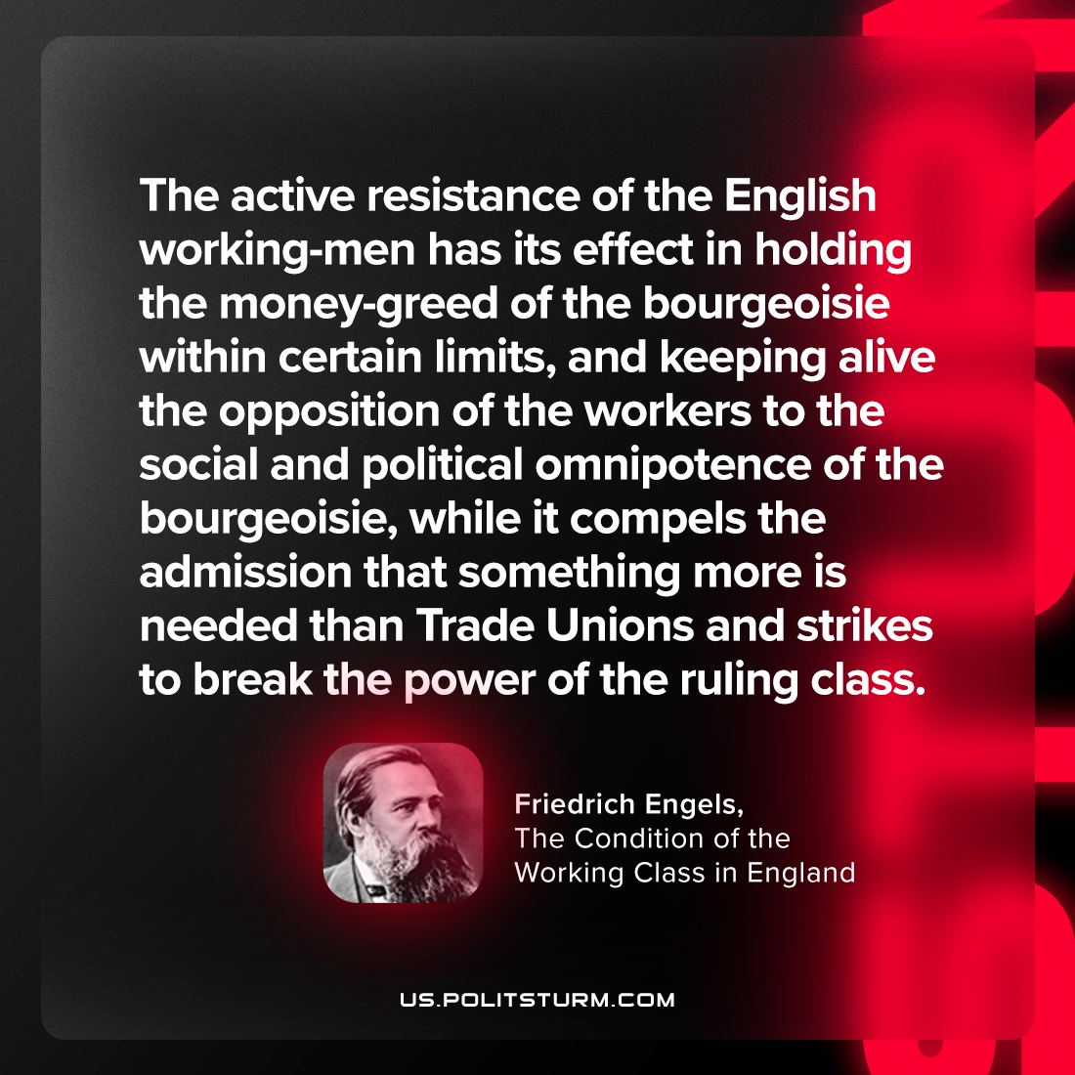

Original article
2023-12-30

"The active resistance of the English working-men has its effect in holding the money-greed of the bourgeoisie within certain limits, and keeping alive the opposition of the workers to the social and political omnipotence of the bourgeoisie, while it compels the admission that something more is needed than Trades Unions and strikes to break the power of the ruling class."
Friedrich Engels, The Condition of the Working Class in England

Original article

