Engels on the Proletariat
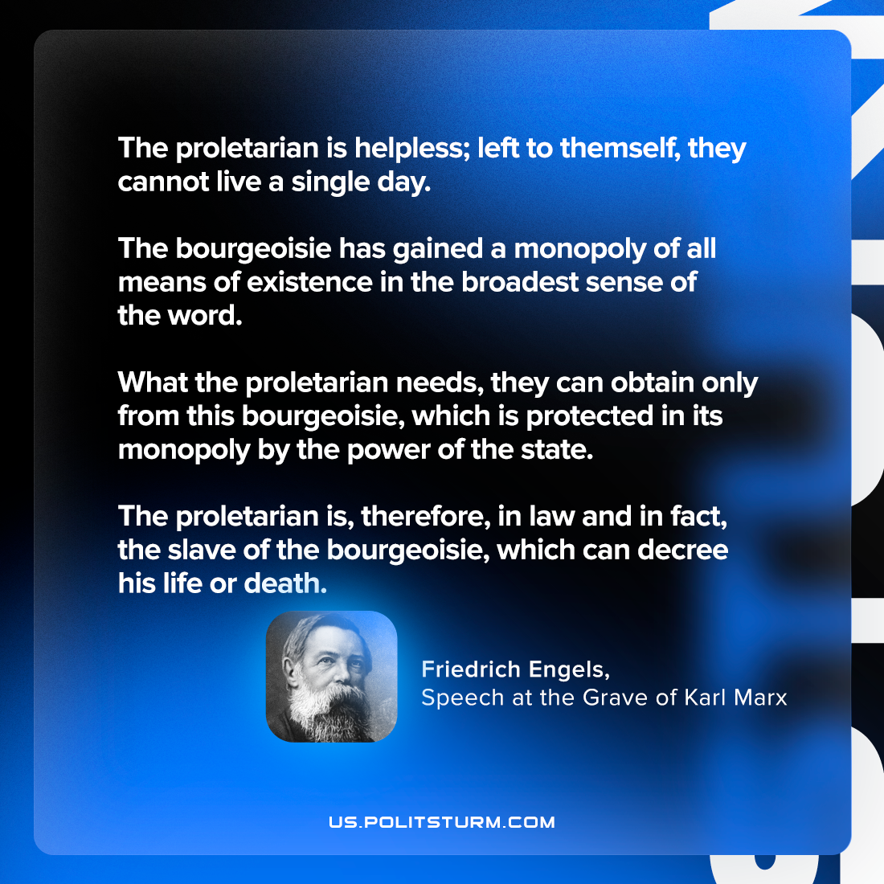

Original article
2023-06-18
1 min read

"The proletarian is helpless; left to themself, they cannot live a single day. The bourgeoisie has gained a monopoly of all means of existence in the broadest sense of the word. What the proletarian needs, they can obtain only from this bourgeoisie, which is protected in its monopoly by the power of the state. The proletarian is, therefore, in law and in fact, the slave of the bourgeoisie, which can decree his life or death."
Frederick Engels, Speech at the Grave of Karl Marx

Original article

