Engels on the Planned Economy
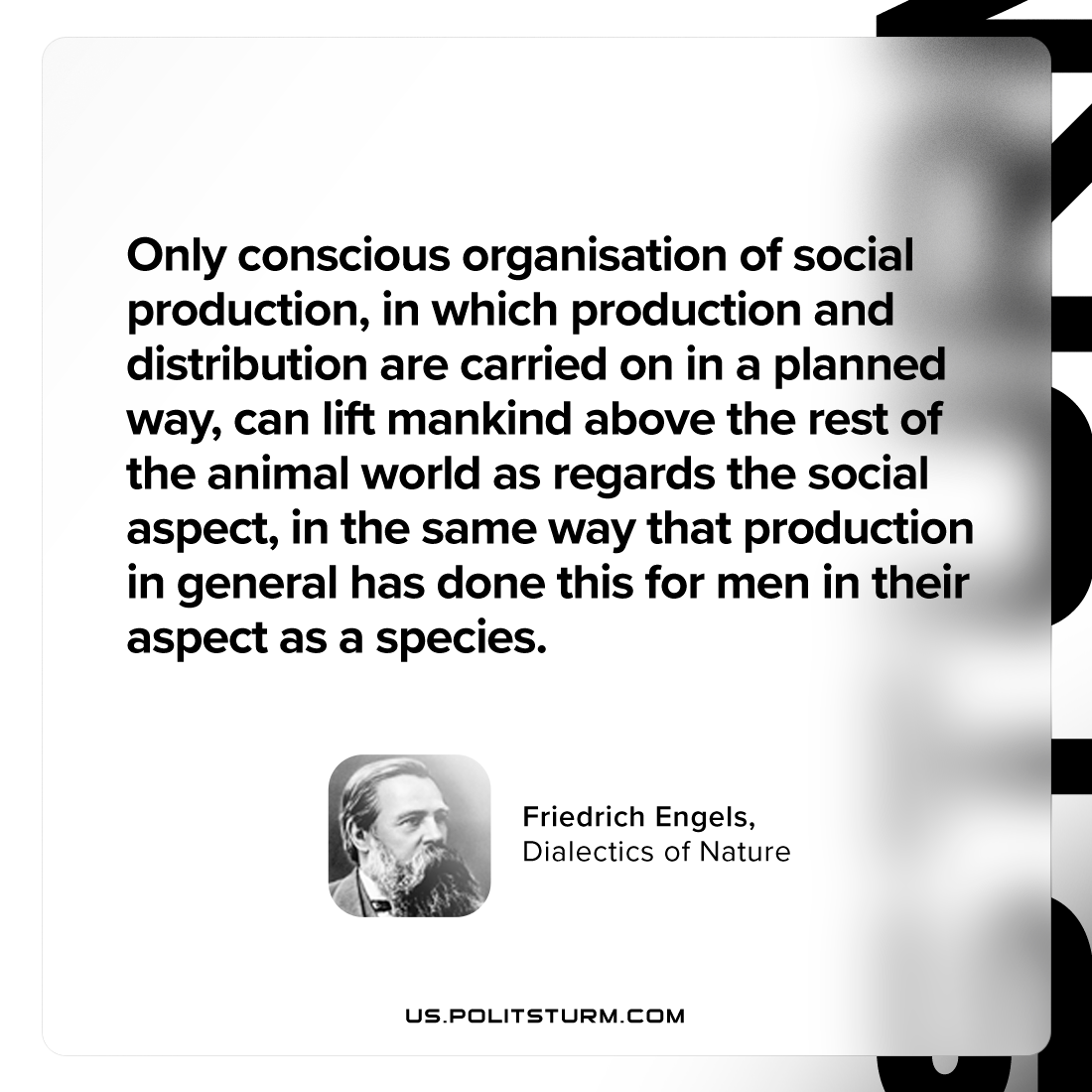

Original article
2023-11-16

"Only conscious organisation of social production, in which production and distribution are carried on in a planned way, can lift mankind above the rest of the animal world as regards the social aspect, in the same way that production in general has done this for men in their aspect as a species."
Friedrich Engels, Dialectics of Nature

Original article

