Engels on the Nucleus of the Labor Movement
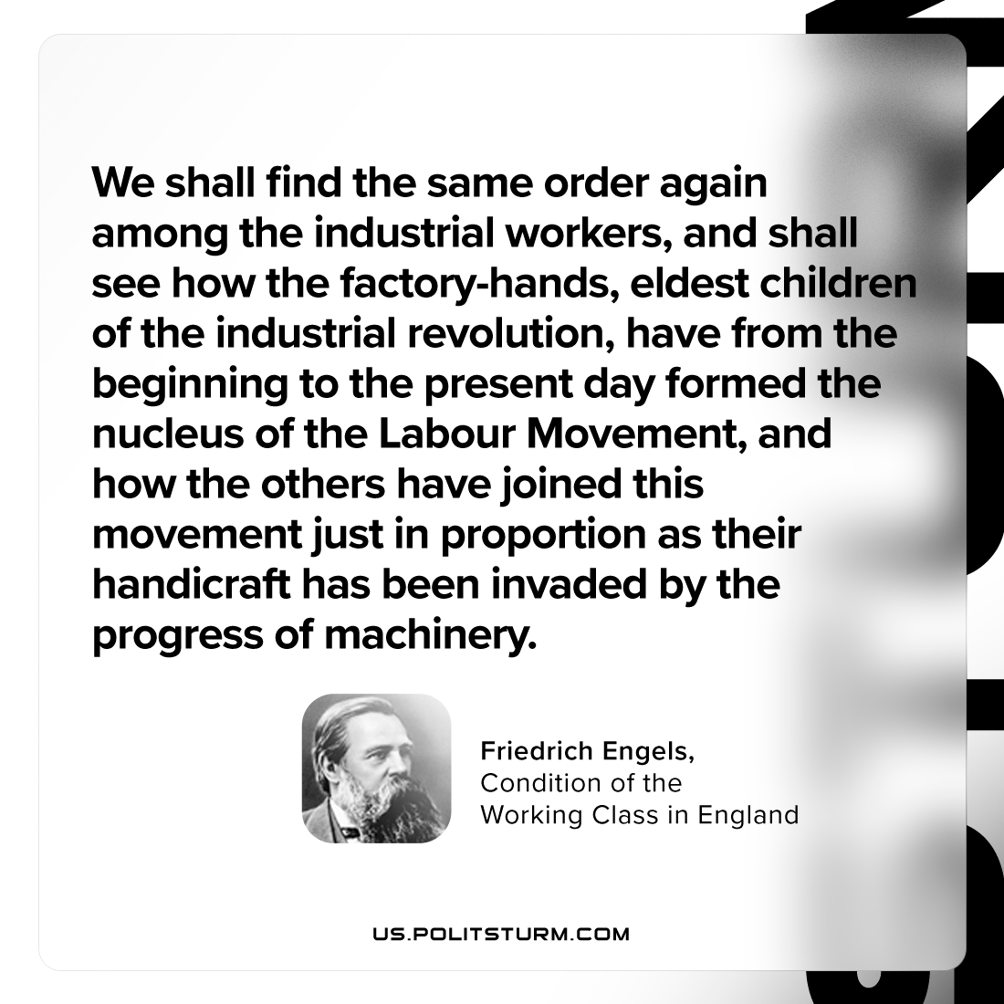

Original article
2024-05-07

"We shall find the same order again among the industrial workers, and shall see how the factory-hands, eldest children of the industrial revolution, have from the beginning to the present day formed the nucleus of the Labour Movement, and how the others have joined this movement just in proportion as their handicraft has been invaded by the progress of machinery."
Friedrich Engels, Condition of the Working Class in England

Original article

