Engels on the Materialist Conception of History
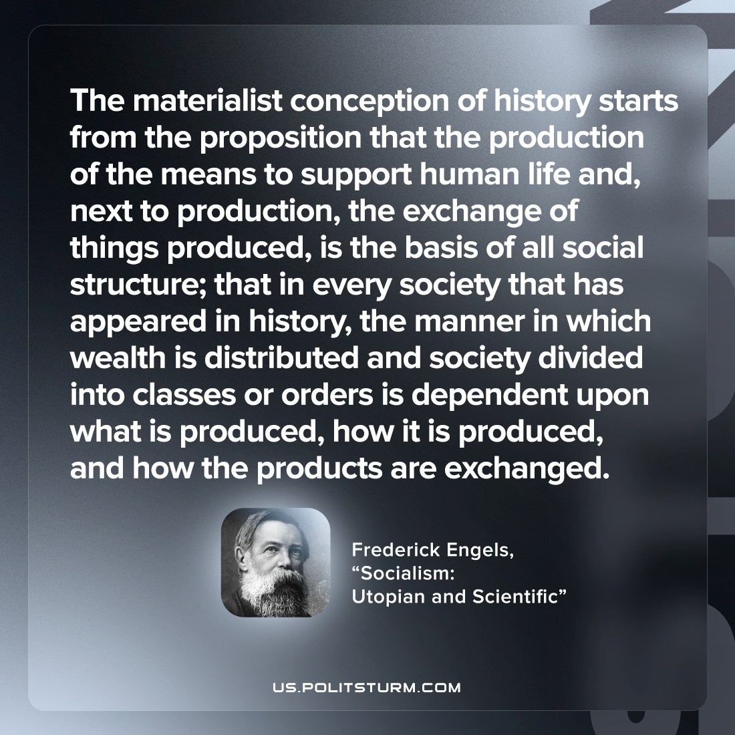

Original article
2022-10-20

The materialist conception of history starts from the proposition that the production of the means to support human life and, next to production, the exchange of things produced, is the basis of all social structure; that in every society that has appeared in history, the manner in which wealth is distributed and society divided into classes or orders is dependent upon what is produced, how it is produced, and how the products are exchanged.

Friedrich Engels, “Socialism: Utopian and Scientific”

Original article

