Engels on the Law Being in Favor of the Capitalist
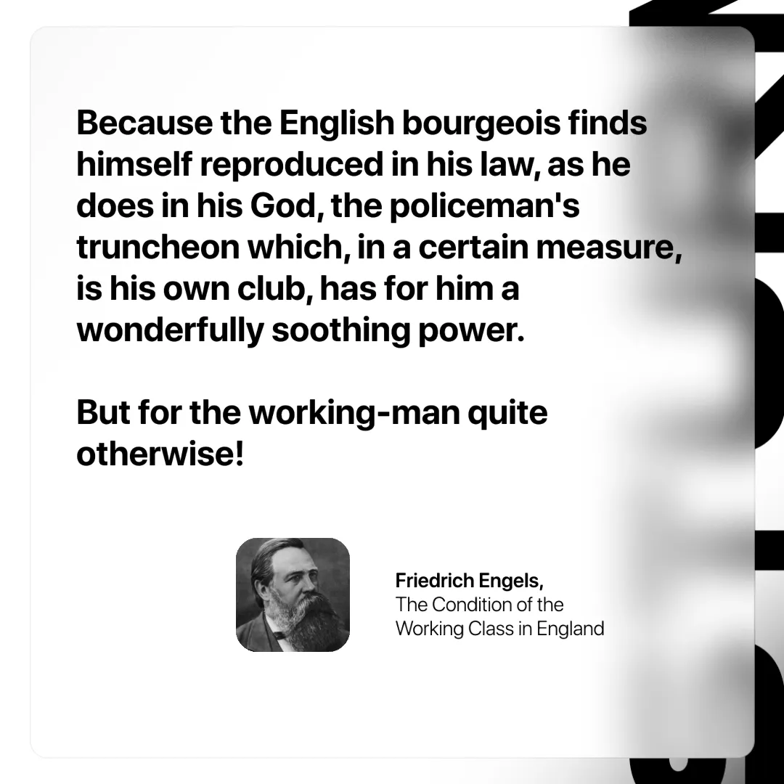

Original article
2025-01-14

“Because the English bourgeois finds himself reproduced in his law, as he does in his God, the policeman's truncheon which, in a certain measure, is his own club, has for him a wonderfully soothing power. But for the working-man quite otherwise!”
Friedrich Engels, The Condition of the Working Class in England

Original article

