Engels on the Interconnectedness between Objects and Processes
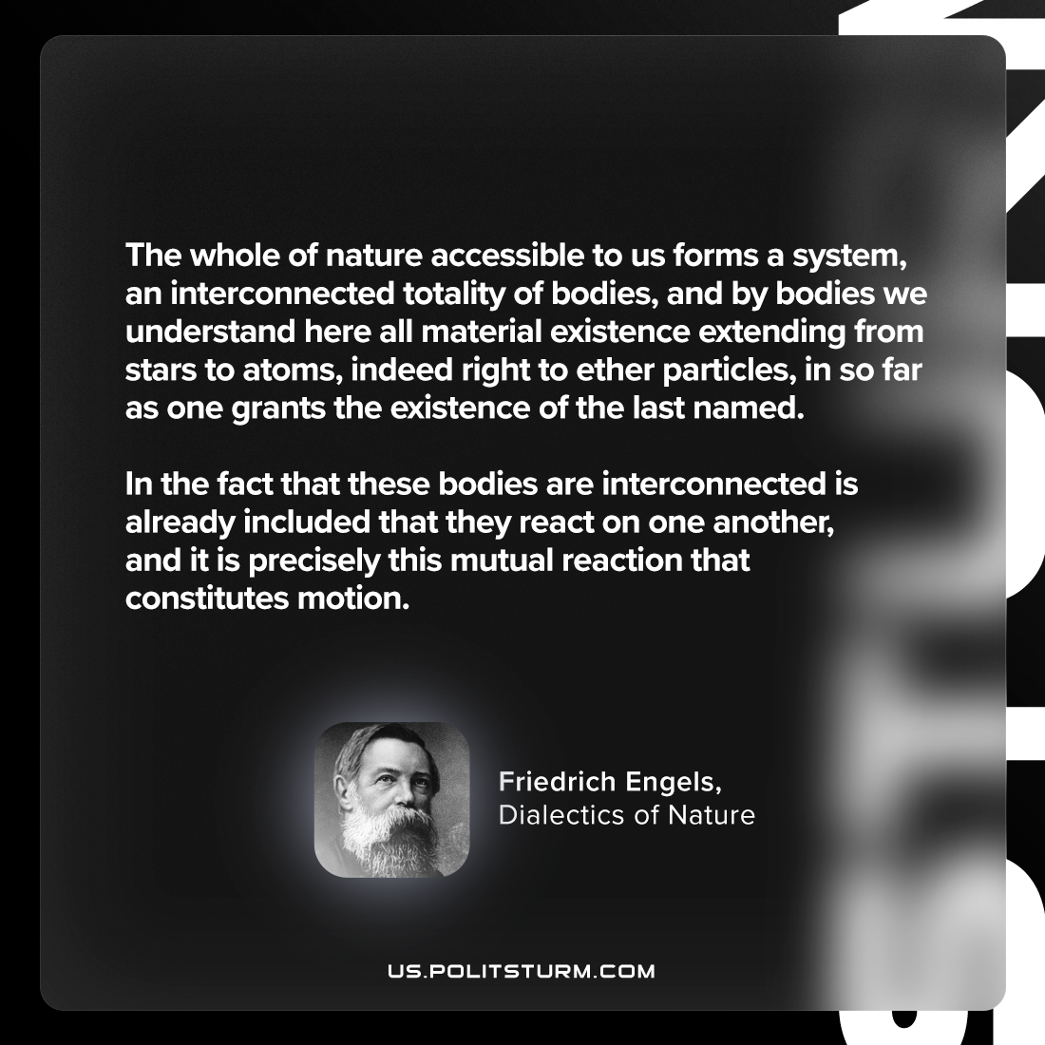

Original article
2024-01-27

"The whole of nature accessible to us forms a system, an interconnected totality of bodies, and by bodies we understand here all material existence extending from stars to atoms, indeed right to ether particles, in so far as one grants the existence of the last named. In the fact that these bodies are interconnected is already included that they react on one another, and it is precisely this mutual reaction that constitutes motion."
Friedrich Engels, Dialectics of Nature

Original article

