Engels on the Increase of the Proletariat
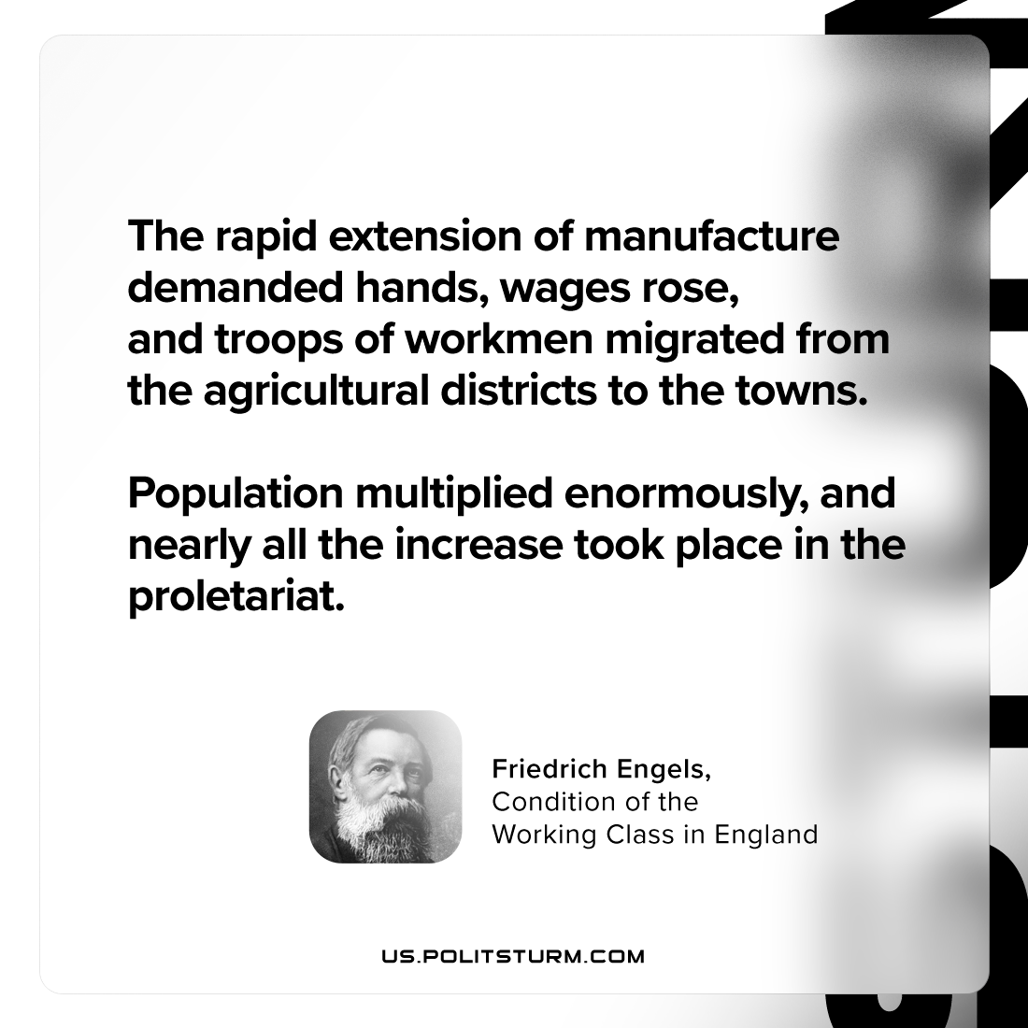

Original article
2024-06-01

"The rapid extension of manufacture demanded hands, wages rose, and troops of workmen migrated from the agricultural districts to the towns. Population multiplied enormously, and nearly all the increase took place in the proletariat."
Friedrich Engels, The Condition of the Working Class in England

Original article

