Engels on the Growth of Industry and the Crisis of Overproduction
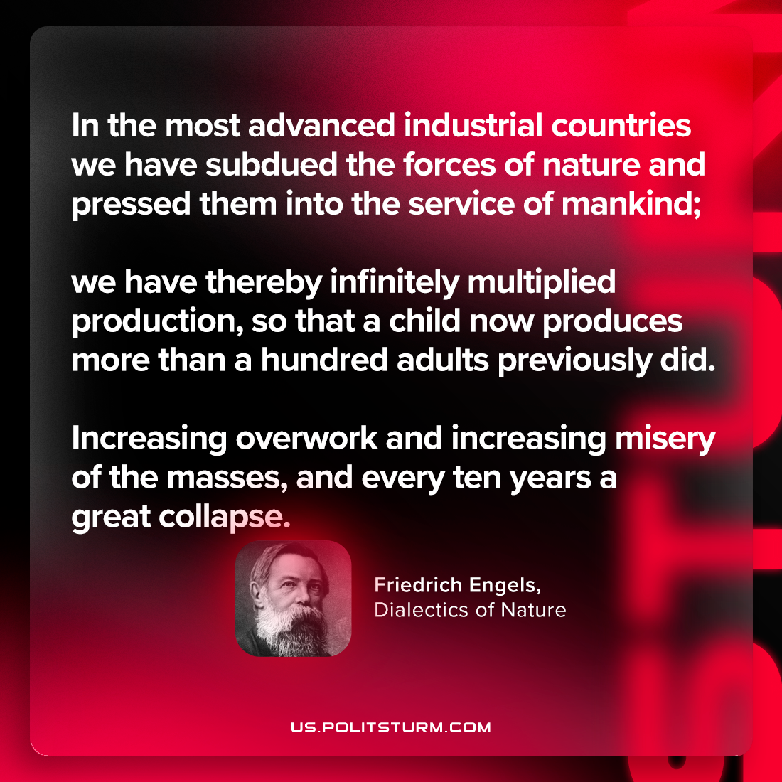

Original article
2023-12-31

"In the most advanced industrial countries we have subdued the forces of nature and pressed them into the service of mankind; we have thereby infinitely multiplied production, so that a child now produces more than a hundred adults previously did. Increasing overwork and increasing misery of the masses, and every ten years a great collapse."
Friedrich Engels, Dialectics of Nature

Original article

