Engels on the Division of Labor Getting out of Control
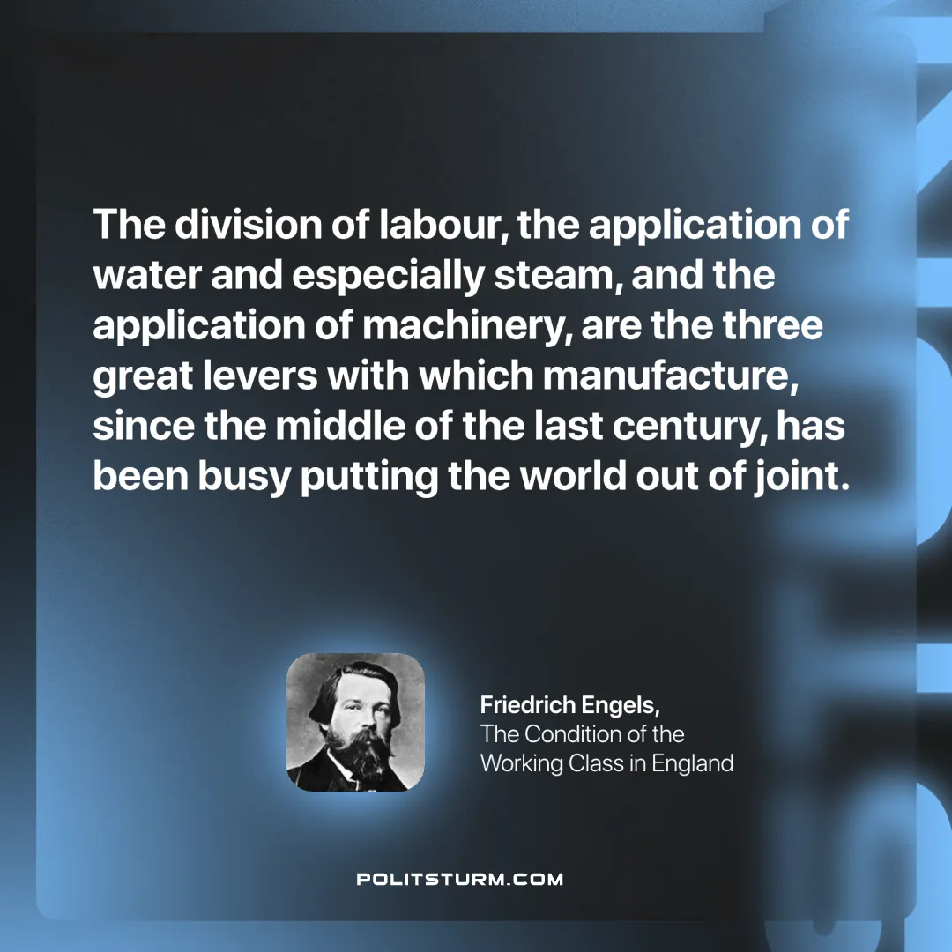

Original article
2025-01-25

“The division of labour, the application of water and especially steam, and the application of machinery, are the three great levers with which manufacture, since the middle of the last century, has been busy putting the world out of joint.”
Friedrich Engels, The Condition of the Working Class in England

Original article

