Engels on the Anarchy of Production
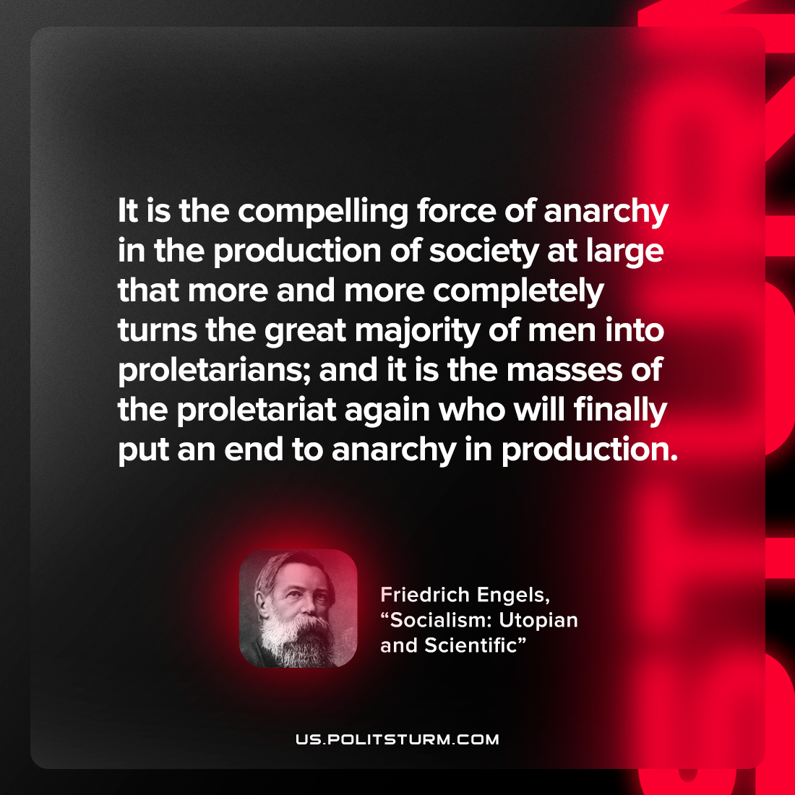

Original article
2022-10-19

It is the compelling force of anarchy in the production of society at large that more and more completely turns the great majority of men into proletarians; and it is the masses of the proletariat again who will finally put an end to anarchy in production.

Friedrich Engels, “Socialism: Utopian and Scientific”

Original article

