Engels on Proletariat and Bourgeoisie
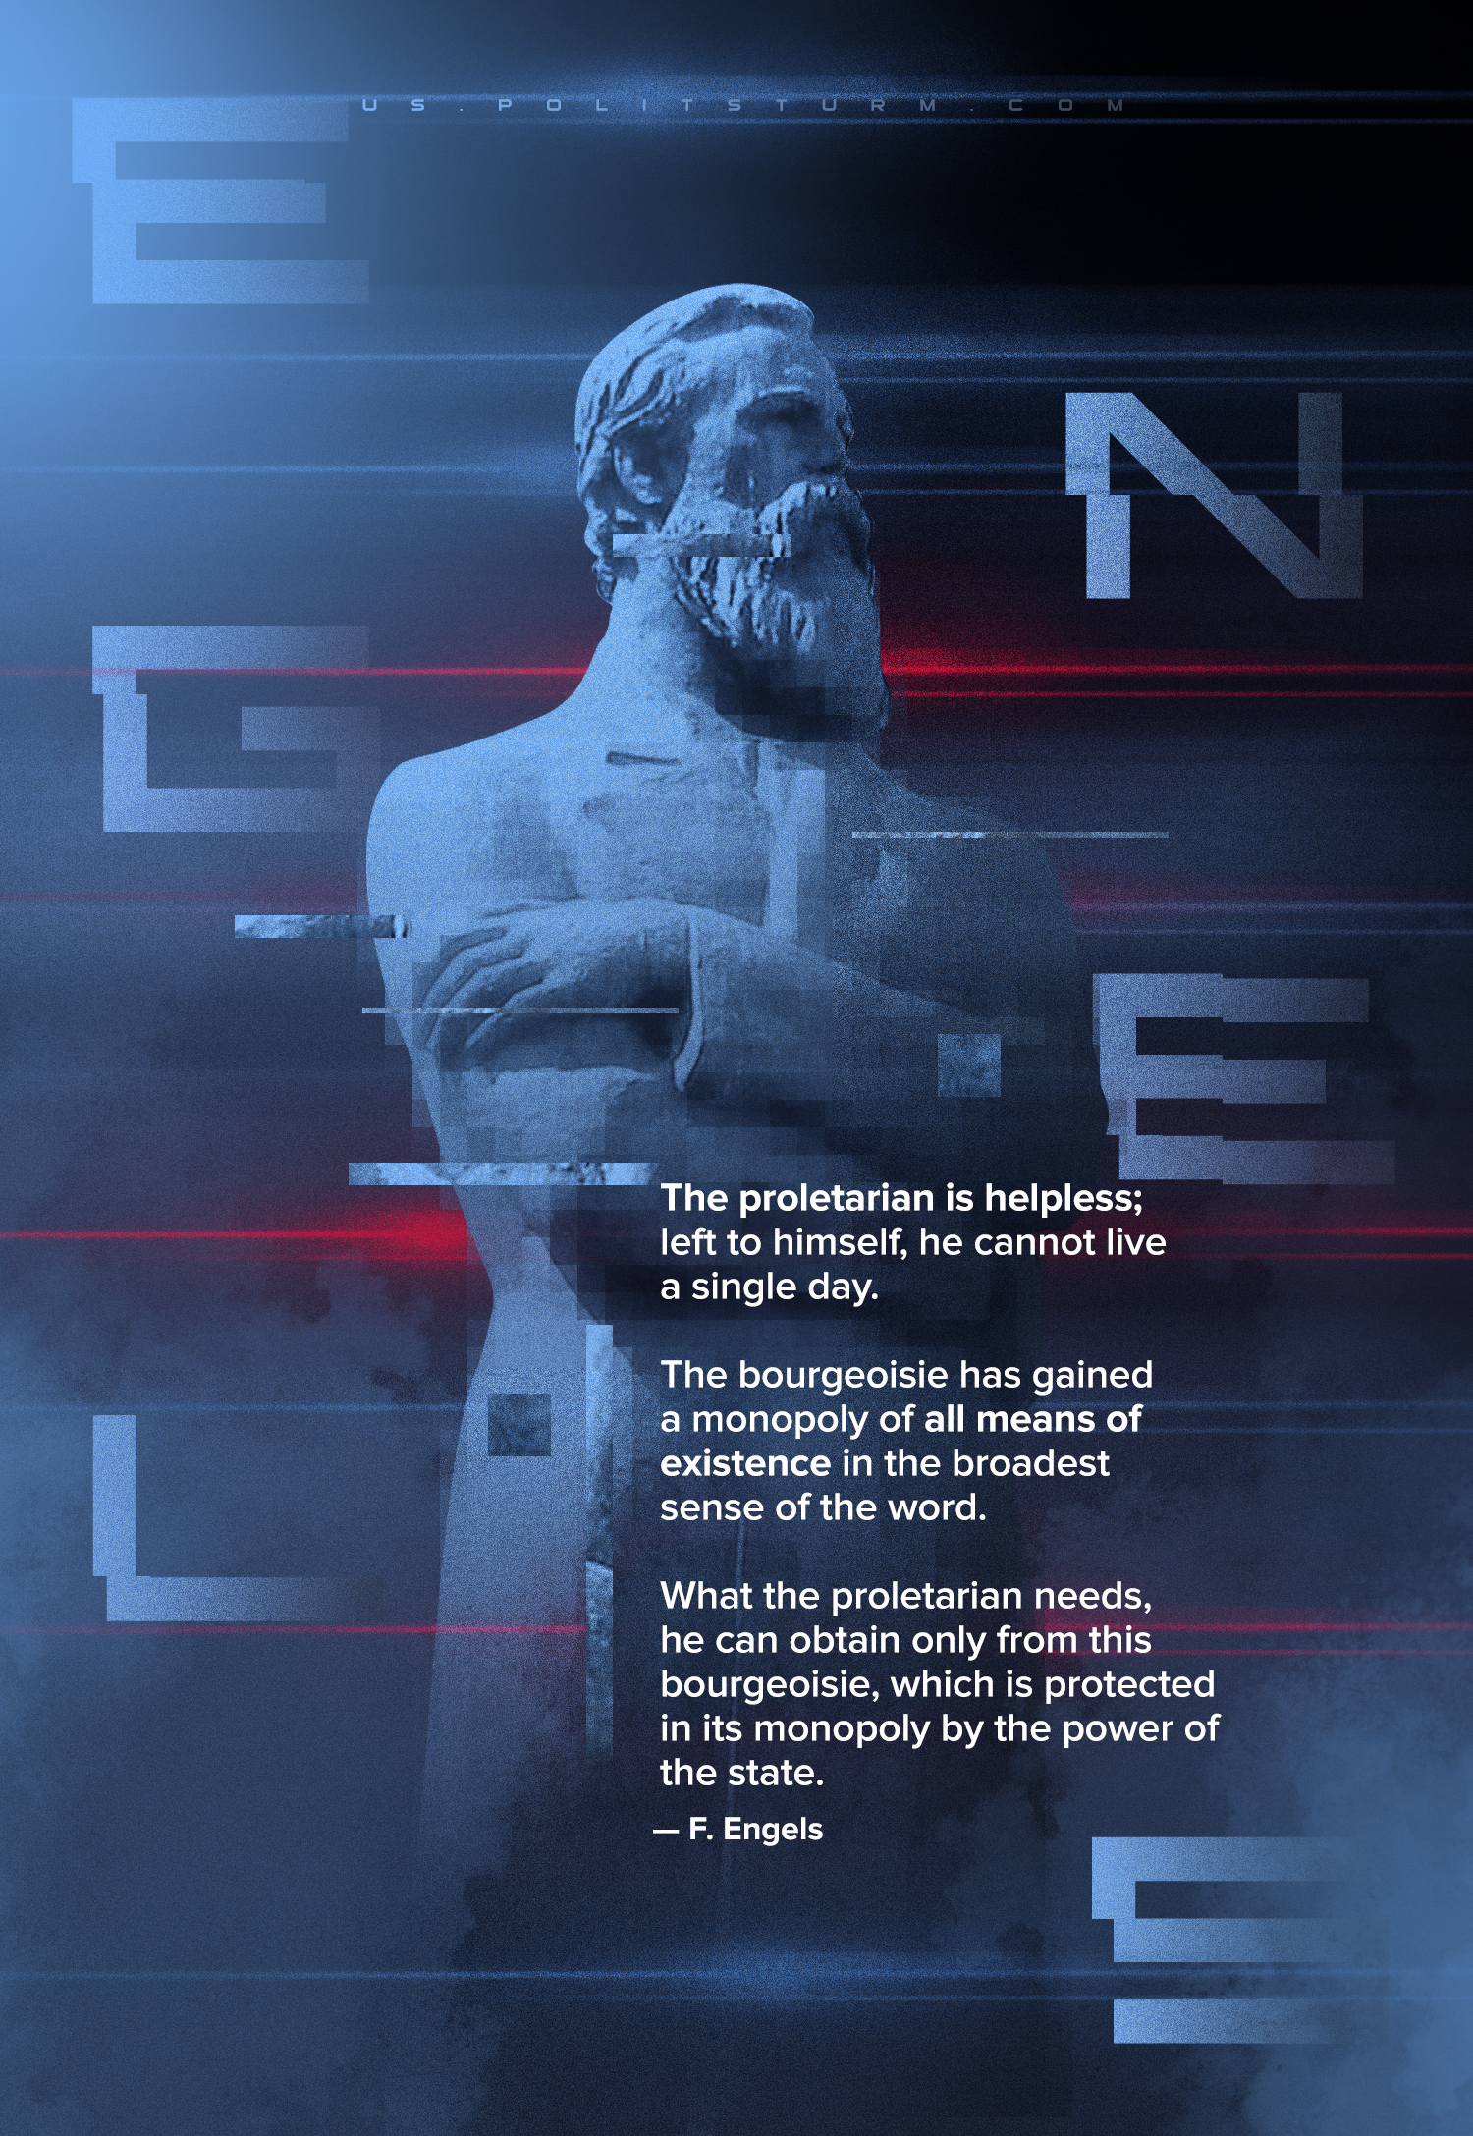

Original article
2022-12-23

"The proletarian is helpless; left to himself, he cannot live a single day. The bourgeoisie has gained a monopoly of all means of existence in the broadest sense of the word. What the proletarian needs, he can obtain only from this bourgeoisie, which is protected in its monopoly by the power of the state."
Friedrich Engels, "Condition of the Working Class in England"

Original article

