Engels on Political Economy
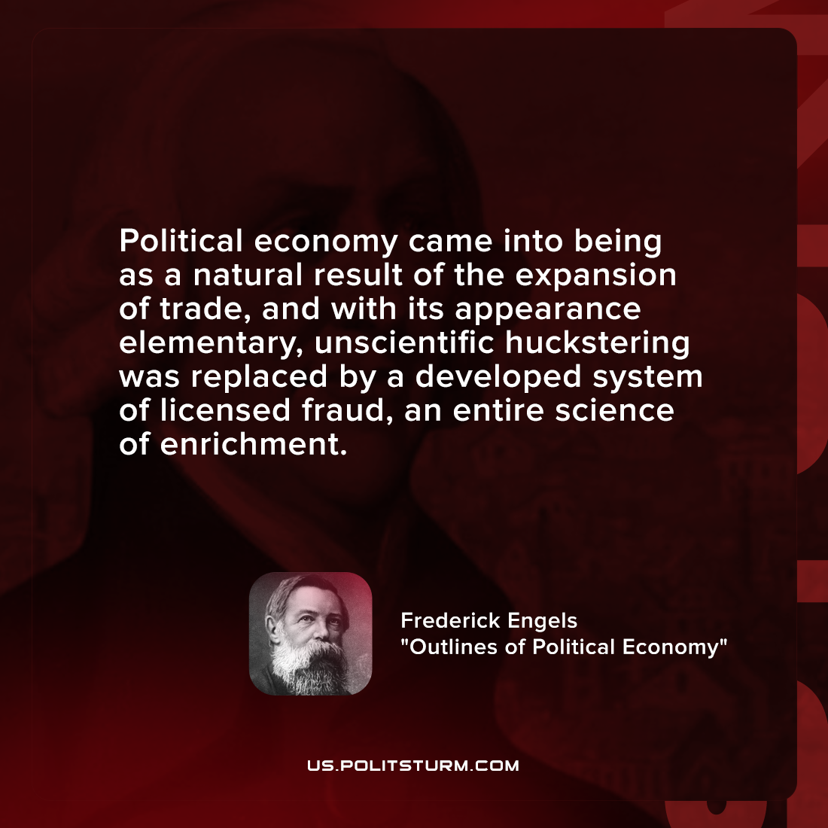

Original article
2022-01-27

Political economy came into being as a natural result of the expansion of trade, and with its appearance elementary, unscientific huckstering was replaced by a developed system of licensed fraud, an entire science of enrichment.

Frederick Engels, “Outlines of Political Economy”

Original article

