Engels on Overproduction
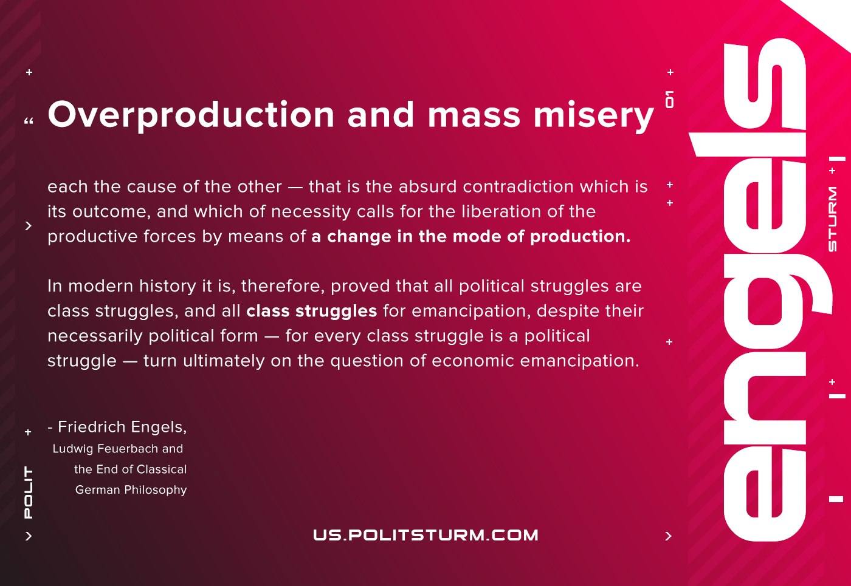

Original article
2020-12-10
1 min read

Overproduction and mass misery, each the cause of the other — that is the absurd contradiction which is its outcome, and which of necessity calls for the liberation of the productive forces by means of a change in the mode of production.
In modern history it is, therefore, proved that all political struggles are class struggles, and all class struggles for emancipation, despite their necessarily political form — for every class struggle is a political struggle — turn ultimately on the question of economic emancipation.
F.Engels. Ludwig Feuerbach and the End of Classical German Philosophy

Original article

