Engels on Materialism
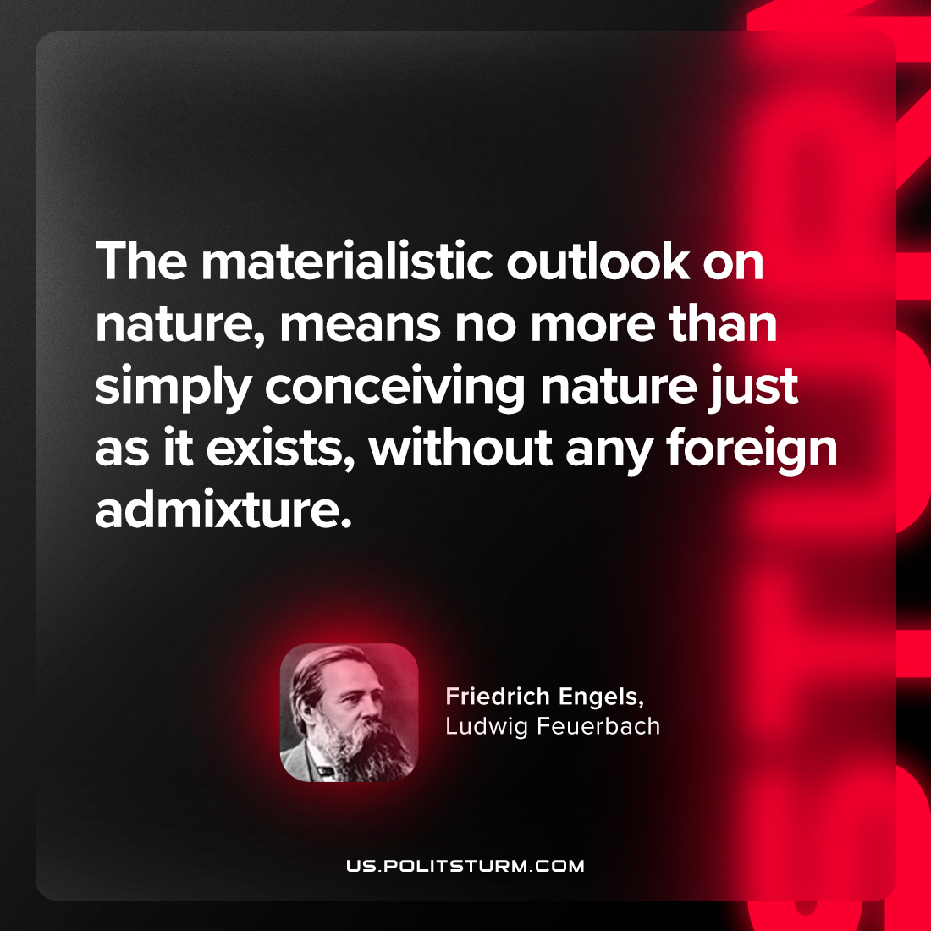

Original article
2023-04-16

"The materialistic outlook on nature, means no more than simply conceiving nature just as it exists, without any foreign admixture."
Friedrich Engels, "Ludwig Feuerbach"

Original article

