Engels on History
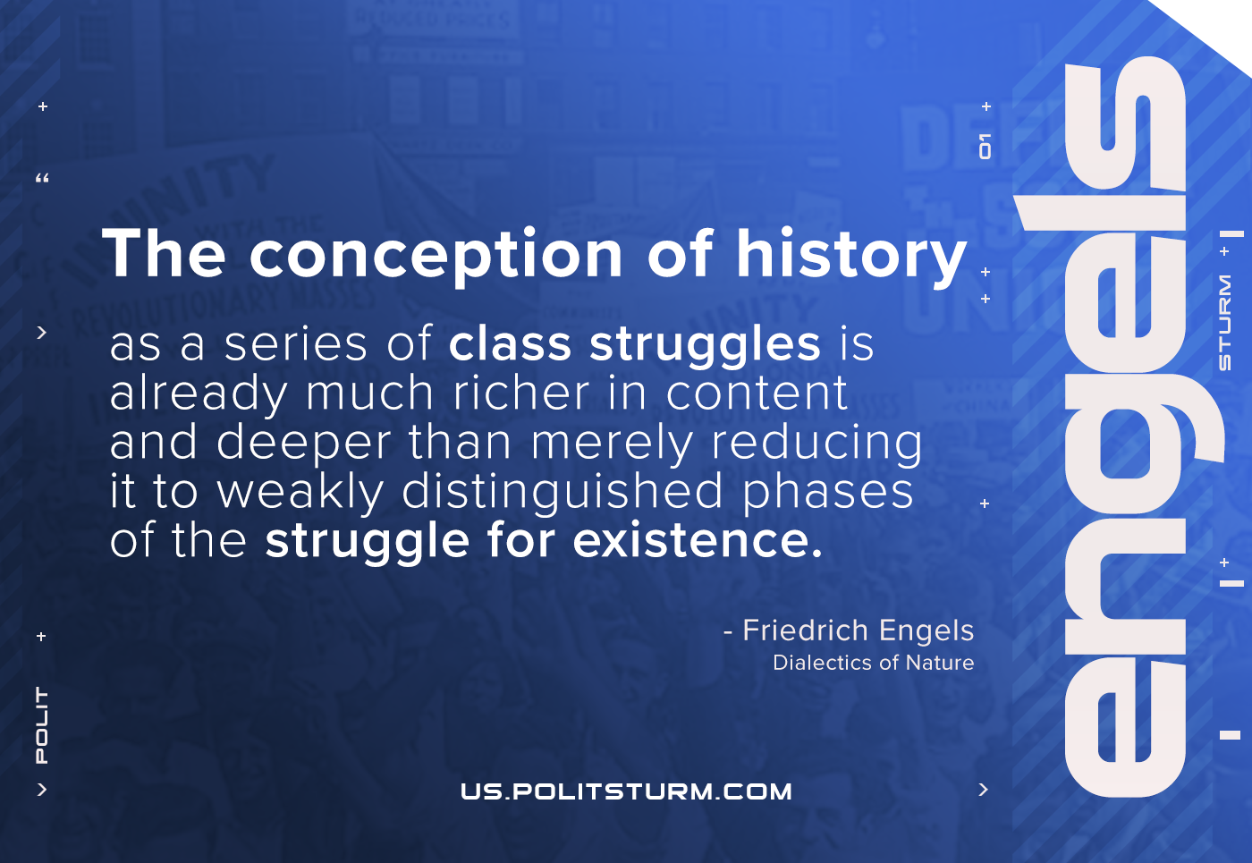

Original article
2021-06-07

The conception of history as a series of class struggles is already much richer in content and deeper than merely reducing it to weakly distinguished phases of the struggle for existence.
Engels, Dialectics of Nature

Original article

