Engels on Freeing Oneself
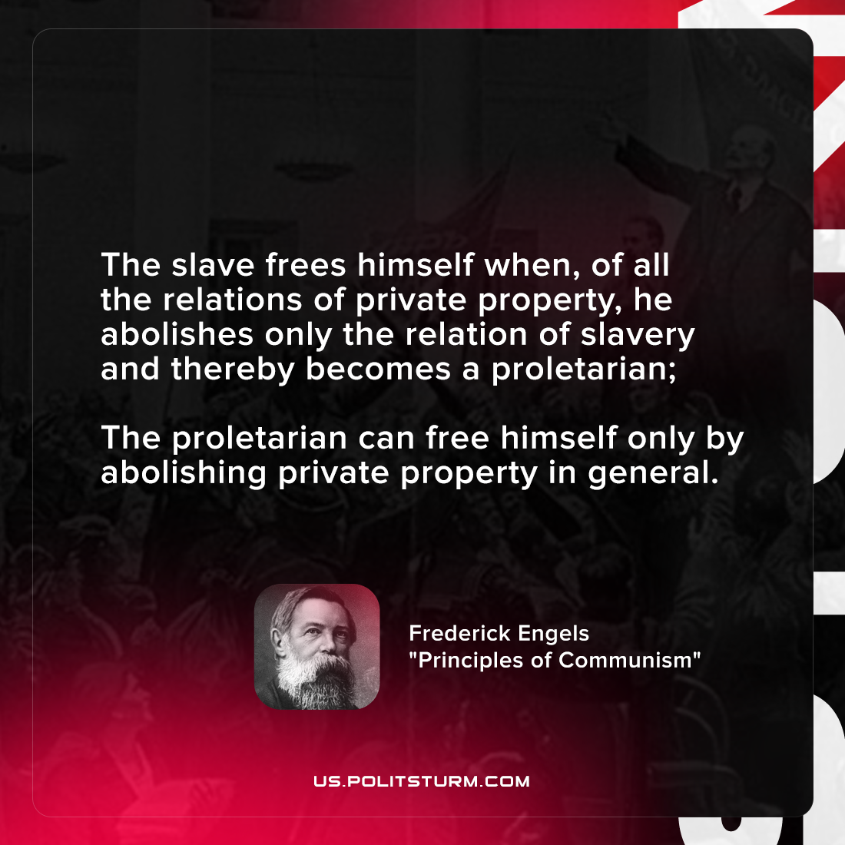

Original article
2021-11-09

The slave frees himself when, of all the relations of private property, he abolishes only the relation of slavery and thereby becomes a proletarian; the proletarian can free himself only by abolishing private property in general.
Frederick Engels, “Principles of Communism”

Original article

