Engels on Freedom
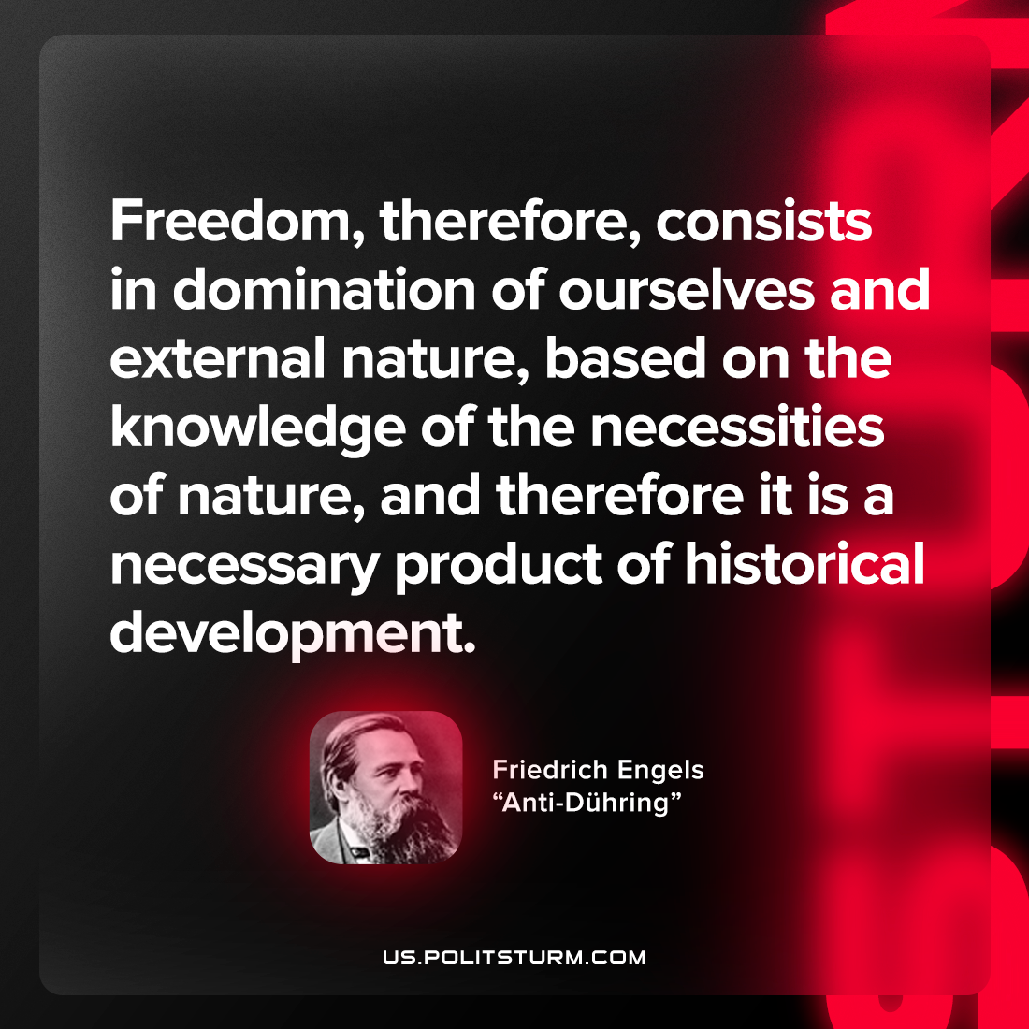

Original article
2022-09-11

Freedom, therefore, consists in domination of ourselves and external nature, based on the knowledge of the necessities of nature, and therefore it is a necessary product of historical development.
Friedrich Engels, “Anti-Dühring”

Original article

