Engels on Free Competition and the Bourgeoisie
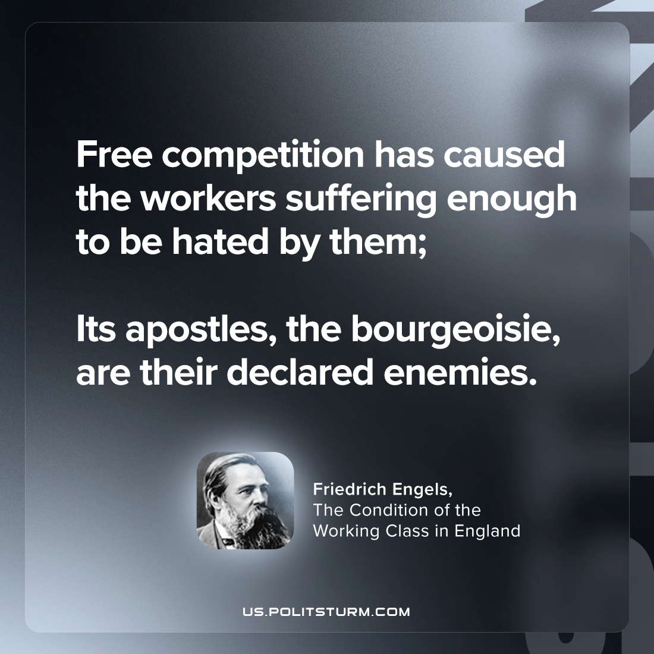

Original article
2023-12-28

"Free competition has caused the workers suffering enough to be hated by them; its apostles, the bourgeoisie, are their declared enemies."
Friedrich Engels, The Condition of the Working Class in England

Original article

