Engels on Exploitation
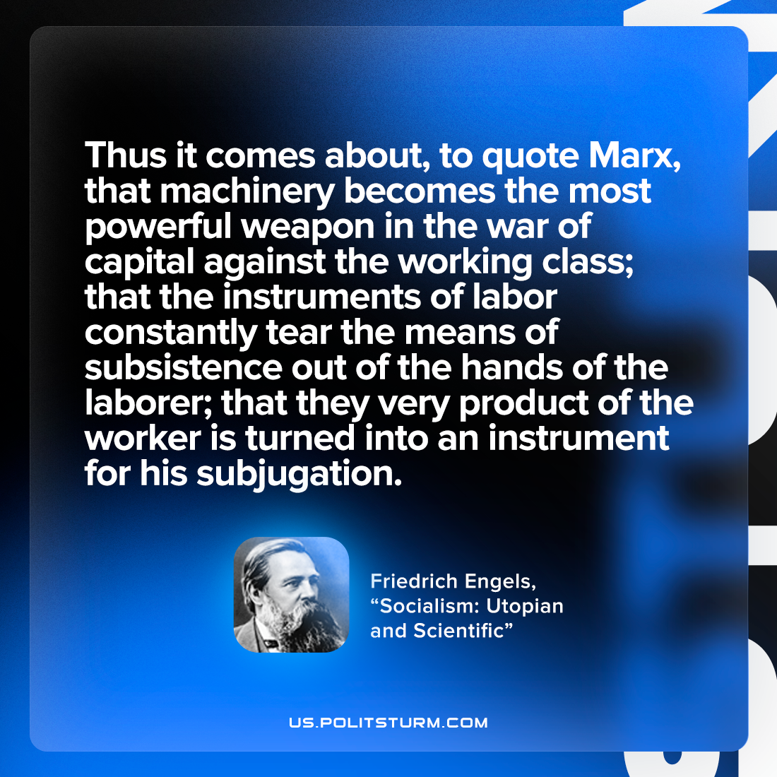

Original article
2022-11-17

Thus it comes about, to quote Marx, that machinery becomes the most powerful weapon in the war of capital against the working class; that the instruments of labor constantly tear the means of subsistence out of the hands of the laborer; that they very product of the worker is turned into an instrument for his subjugation.
Friedrich Engels, “Socialism: Utopian and Scientific”

Original article

